

FALCON’s Response to Festo
for Supply Of Conveyor Automation – 2K
Option - 4
August 1, 2024

Kind Attention –
M/s Festo

Offer Ref: F24-00322 Option 4 ; Date: 01-08-2024

Subject – Techno -Commercial Offer of Conveyor Automation System 2K PPH

We are pleased to submit our Techno-Commercial Offer in response to your RFP.
As you will note, we have done an in-depth data analysis and evaluated various solution options best suited for your requirements, along with the information collected during the meetings and discussions with you, we have put together a detailed technical proposal laid out in various sections and sequenced to enable you to understand our proposed solution and to re-enforce our commitment to being your partner in this strategic initiative.
In subsequent sections, we have highlighted the capabilities and experiences of Falcon Autotech with sections on our Intra-logistics Automation Technologies and references.
To conclude, I would like to add my personal commitment on behalf of Falcon Autotech. As we move through the RFP process, please do not hesitate to contact me and my team. We will be pleased to assist you with any further information or clarifications that you might have.
Best Regards,
Sandeep Bansal
Chief Business Officer

Response to RFP for
Conveyor Automation 2K PPH Throughput
(Kolkata)

Proposal Reference – F24-00322 – Option 4

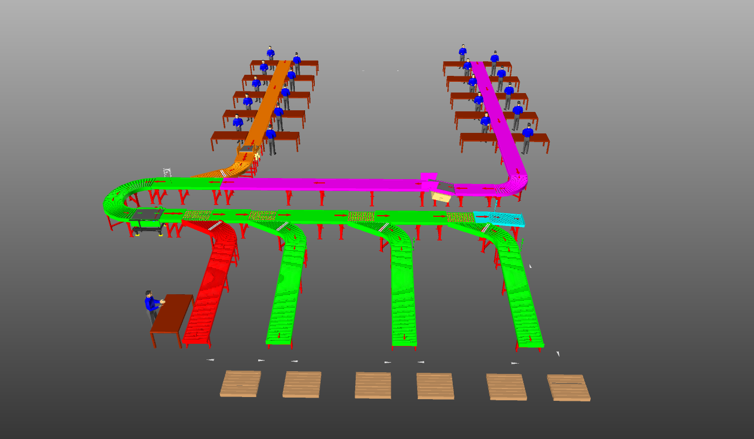

G Level

Table of Contents
1. Glossary 6
2. Executive Summary 7
3. Company Profile 8
4. Falcon’s Experience and Achievements in Sortation Space Globally 12
5. Reference Projects 14
5.1 Project 1- (CEP Festo, India) 14
5.2 Project 2- (Festo – E-Commerce, India) 15
5.3 Project 3- (Ecommerce Festo, India) 16
5.4 Project 4- (CEP Festo, UK) 17
5.5 Project 5- (CEP Festo, Sydney) 18
6. About Falcon 19
7. Handled Parcel Spectrumions Minimum Maximum 26
7.1 Product size Conveyable on the entire system. 26
7.2 Parcels to be loaded on Conveyor/Sorter shall have the following characteristics: 26
7.3 Parcel not loadable on the system 27
7.4 Types of Products 27
8. Proposed System Description 28
8.1 Objective 28
8.2 Summary of the System 28
8.3 Main benefits of the proposed solution 29
9. Layout View 29
10. Proposed System Capacity 30
10.1 System Capacity at various areas 30
11. System description 30
11.1 Infeed Lines and Loop 30
11.2 Outbound Sorter 31
12. System Components 32
12.1 Powered Roller Conveyor 32
12.2 Accumulation Conveyor 33
12.3 PVC Belt Conveyor 34
12.4 Powered Roller Turns & Merges 35
12.5 Side Barcode Scanners 36
12.6 Swivel Wheel Sorting Unit – Falcon 37
13. Proposed System Technical Details/BOM 38
13.1 Mechanical equipment 38
13.2 Electrical Equipment 38
13.3 Control System 39
14. High Availability Server Specifications 40
15. Falcon’s WCS CONTROLIT 41
16. Key Component Makes 42
17. Safety 42
17.1 Push Buttons 42
18. Automation Management System (AMS) 43
18.1 Issue Logging 43
18.2 Preventive Maintenance Check List 44
18.3 Predictive Maintenance 44
18.4 Training Portal 45
18.5 Operational Analysis 45
19. Program Organisation 46
19.1 Program Management 46
20. Warranty Period 47
21. Exclusions 48

Glossary
S. No. | Term | Description
1 | RFQ | Request For Quote
2 | PPH | Parcels Per Hour
3 | AC | Alternating Current
4 | DC | Direct Current
5 | PLC | Programmable Logic Controller
6 | IT | Information Technology
7 | BOQ | Bill Of Quantity
8 | I/O | Input/ Output
9 | PDP | Power Distribution Panel
10 | PC | Personal Computer
11 | UPS | Uninterrupted Power Supply
12 | SWEDI | Swivel Wheel Divert

Executive Summary
Falcon Autotech is pleased to confirm its great interest in responding to this Festo RFQ of Conveyor Automation System. Our team has been working closely with the relevant stakeholders, with a clear commitment to listening, understanding your needs, and ensuring this project's success.
Following the same objective for the Festo Conveyor automation system, we are happy to offer a compliant solution meeting all technical and operational requirements at competitive price, delivering key results.

Our solution is based on the following key characteristics:

Conveyor Automation System 2K PPH:-

• Two Dedicated lines for loading final order carton (1st presently & 2nd in future).

• SWEDI Diverters are placed to Divert the carton at final destinations.

Company Profile
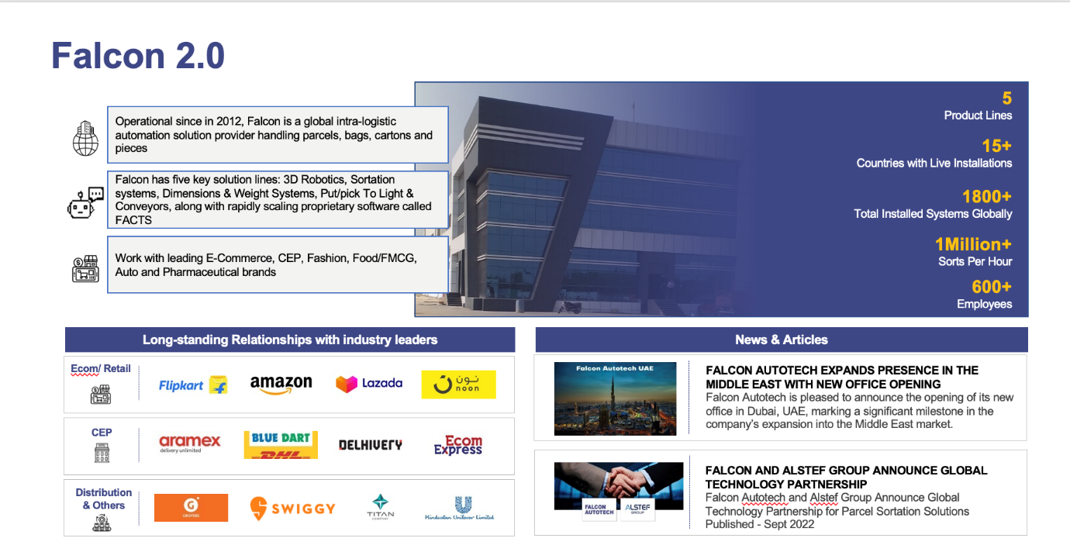
Falcon Autotech (Falcon) is a global intralogistics automation solutions company. With over 10 years of experience, Falcon has worked with some of the most innovative brands in E-Commerce, CEP, Fashion, Food/FMCG, Auto and Pharmaceutical Industries. With our proprietary software and robust hardware integration capabilities, Falcon designs, manufactures, supplies, implements, and maintains world-class warehouse automation systems globally. Falcon’s strong research and development team and the continuous focus on innovation reflect our strong solution line around Sortation, Robotics, Conveying, Vision Systems and IOT. Falcon has done over 1,800 installations across 15 countries on four continents.
Falcon Autotech is currently among the top 15 intralogistics automation company, our vision is to become top 10 intralogistics automation company in our focused product lines.
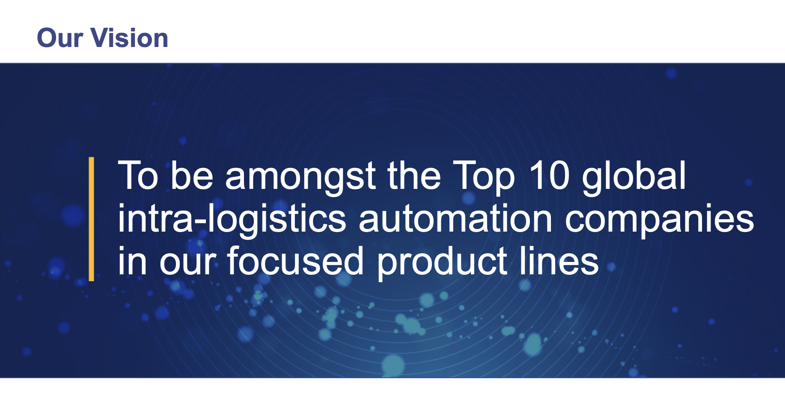

The team started out in 2004 solving special purpose automation problems for Festos and later established Falcon Autotech in 2012 with strong focus on building standard technology stack spanning across Hardware, Firmware and Software to tackle bigger Supply Chain problems around warehouse automation and material handling. Over the decade, Falcon has made rapid strides and has carved out a niche in some of the world's most cutting-edge technologies: Sortation, Robotics, Conveying, Vision Systems and IOT.

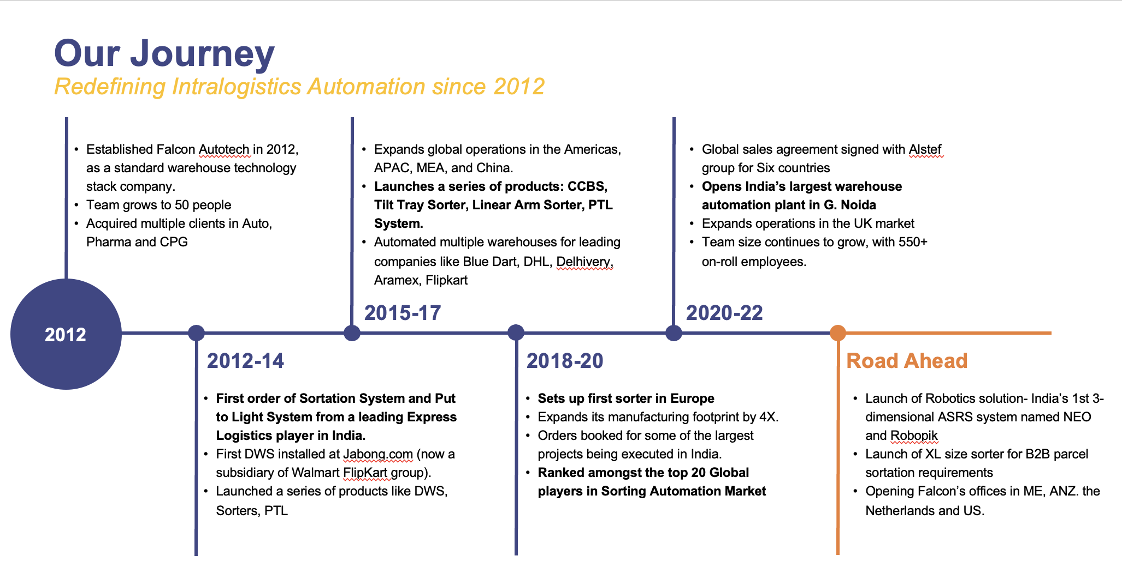
As a leading player in the intra-logistics automation space, Falcon continuously strives to improve the operational efficiencies and accuracies for its Festos through its domain knowledge and experience in addition to its wide range of products and solutions. In order to be able to live up to the high expectations set forth by our Festos, the team at Falcon realizes the importance of taking up selective applications in focused Industries and deliver world class projects in return.
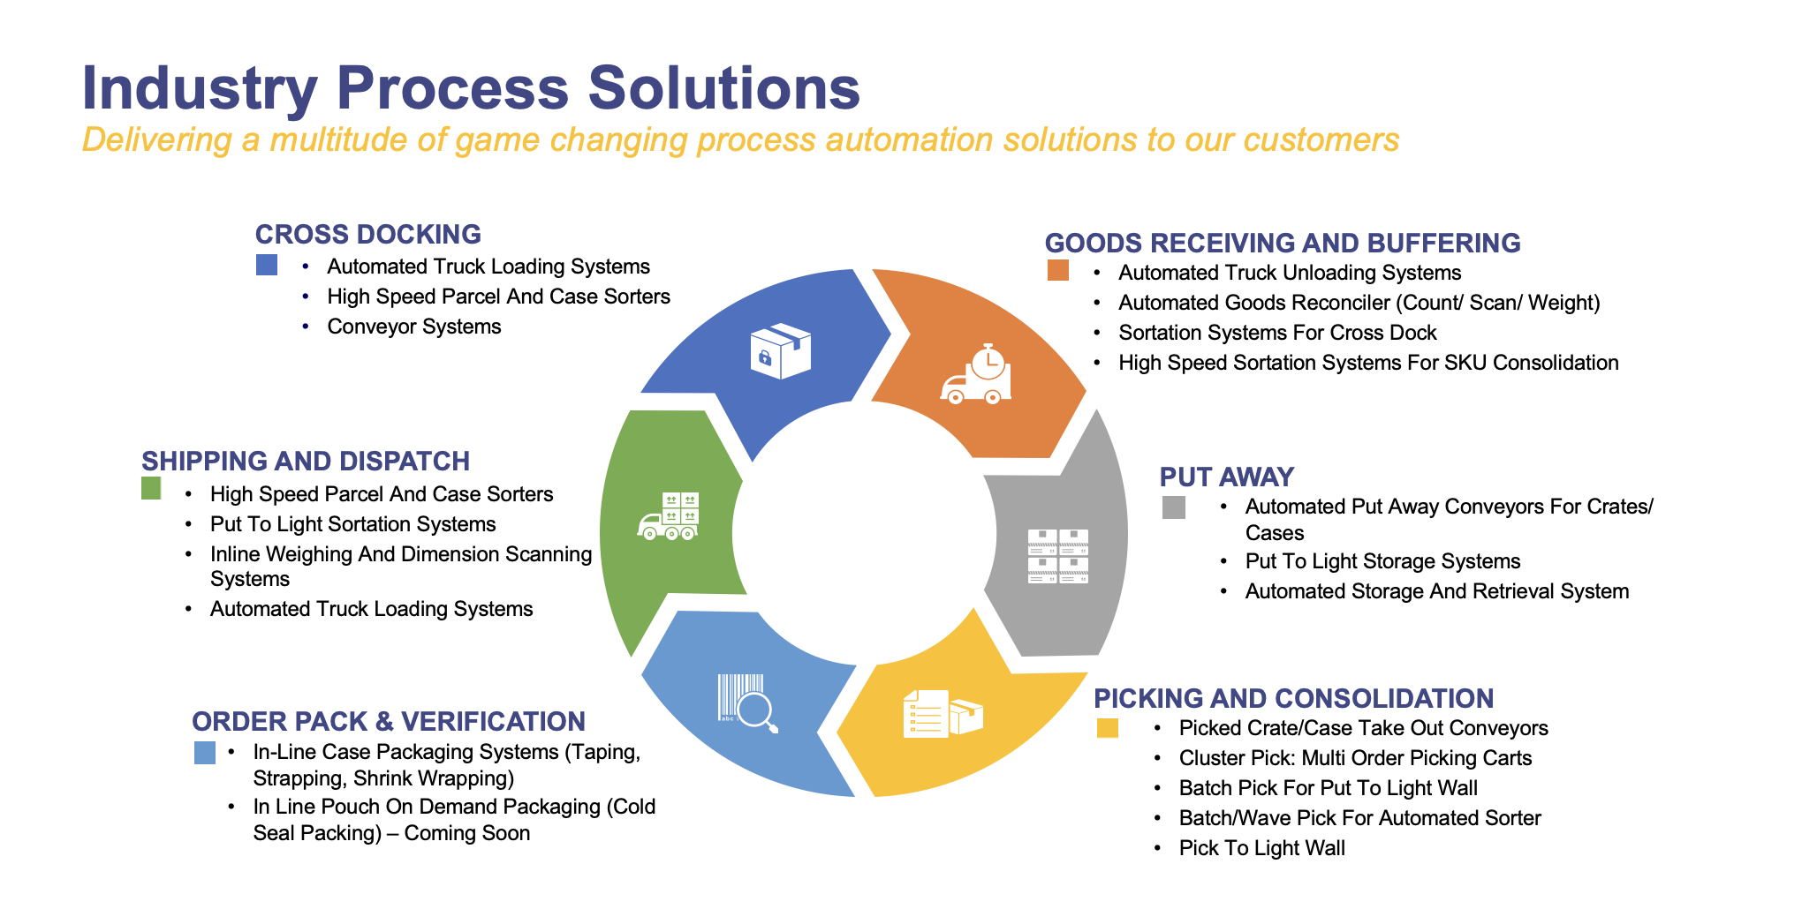

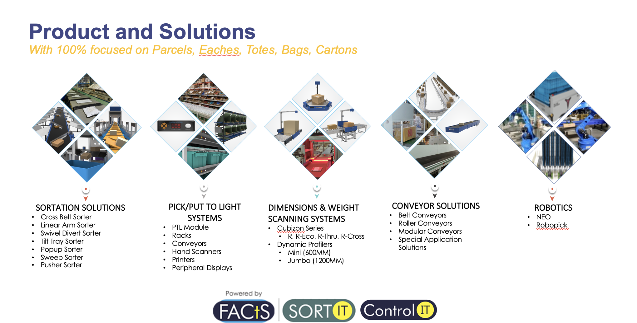

Falcon Autotech has successfully delivered warehouse automation solutions based on smart and innovative combinations of above product lines for effective materials handling, sortation and movement. The process is controlled in real-time by our in house WCS applications. These solutions considerably cut the need for manual operations, improve working conditions and ensure the highest accuracy of the entire process up to final delivery to the recipient.
Over the last 10 years, Falcon has worked with some of the most innovative brands worldwide and has established long standing partnerships. These brands are testimony of our strong focus on delivering superior customer satisfaction and offering end-to-end intralogistics solutions.

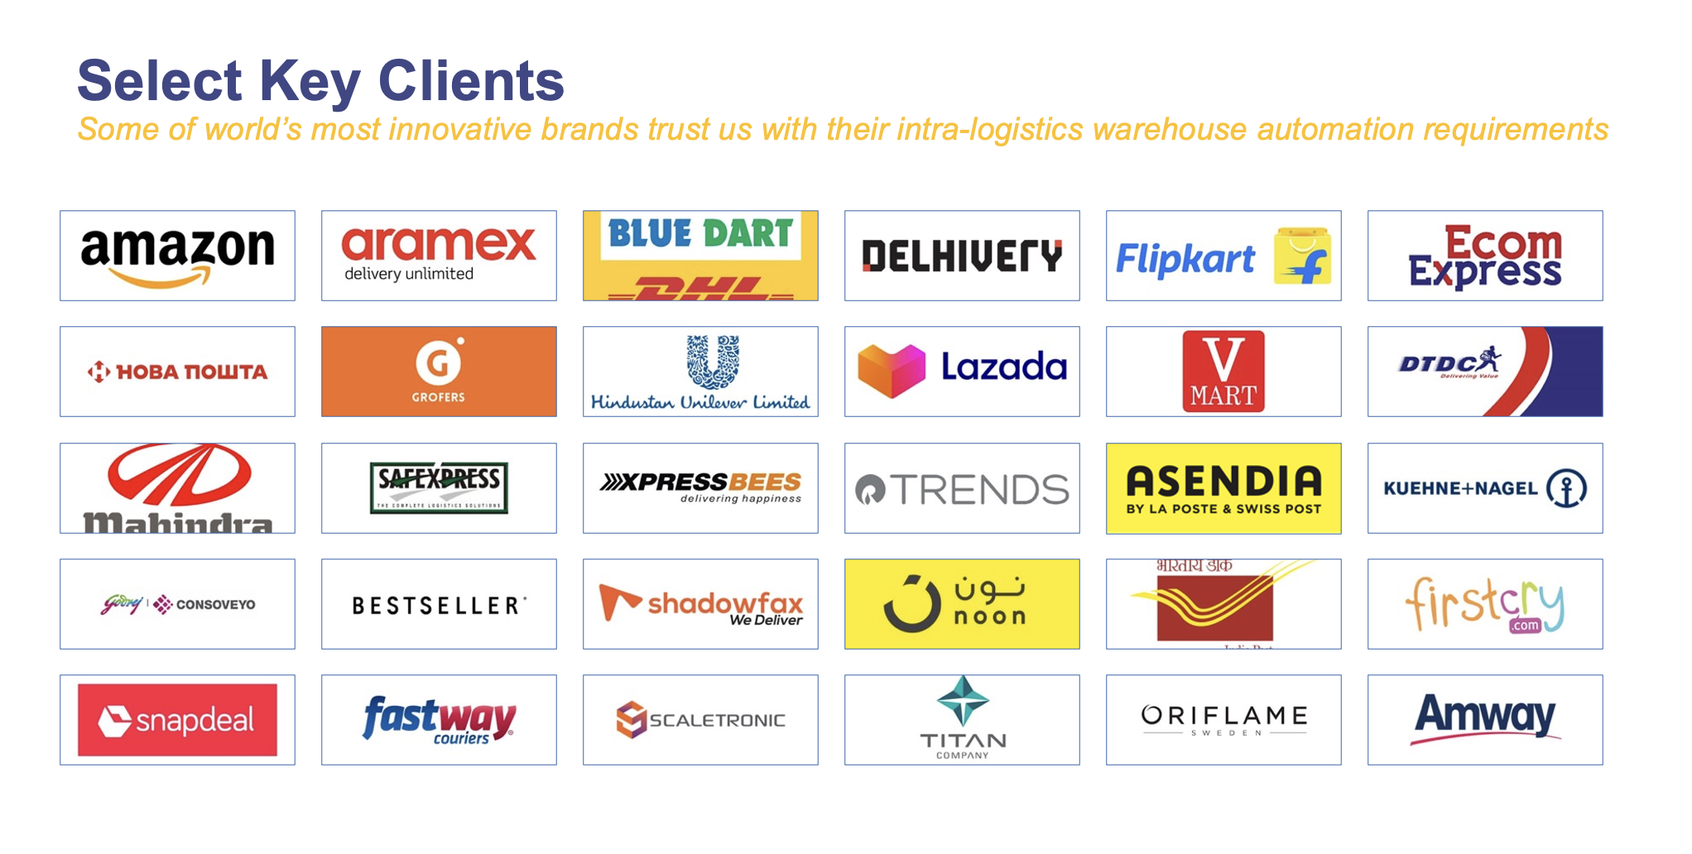
With over 1,800 installations, today Falcon’s systems are used all over the globe. Falcon has highly motivated team of 600+ employees supported by over 15 global partners who help us design, manufacture, deliver and maintain automation solutions globally.

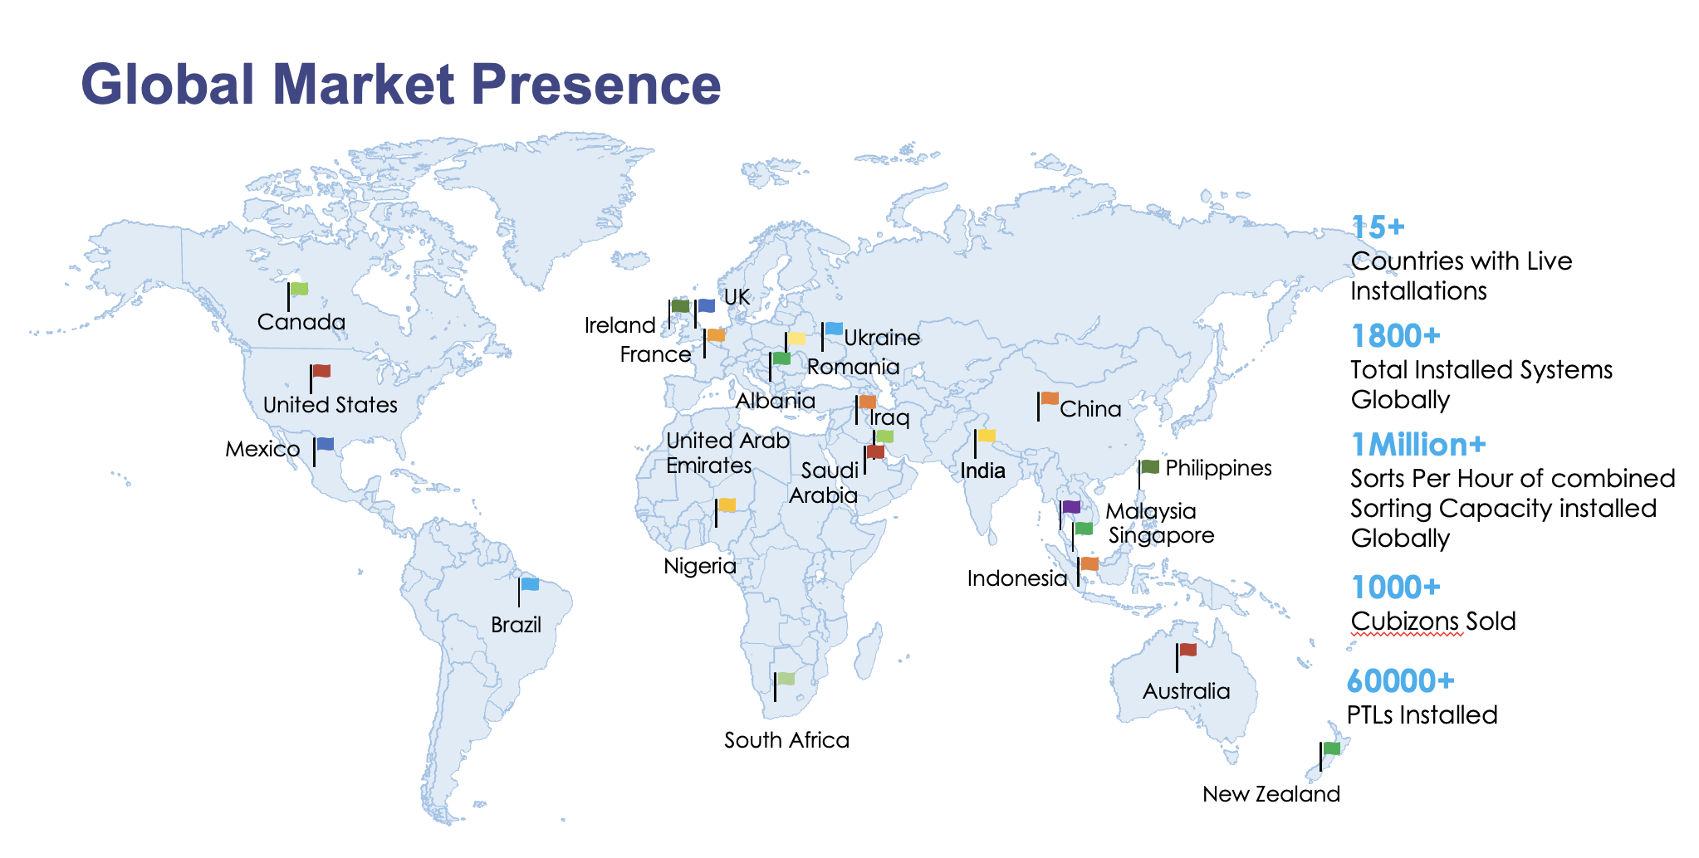

Falcon’s Experience and Achievements in Sortation Space Globally
- Ranked among Top 20 Sortation System Suppliers globally. Only company from APAC/EMEA Region.
- Currently possess one of the World’s largest portfolios in Sortation Technologies: 7 In-house technologies.
- Total installed capacity of 10 million Shipments per day worldwide.
- Only company to be able to offer a Fully Integrated AMS.

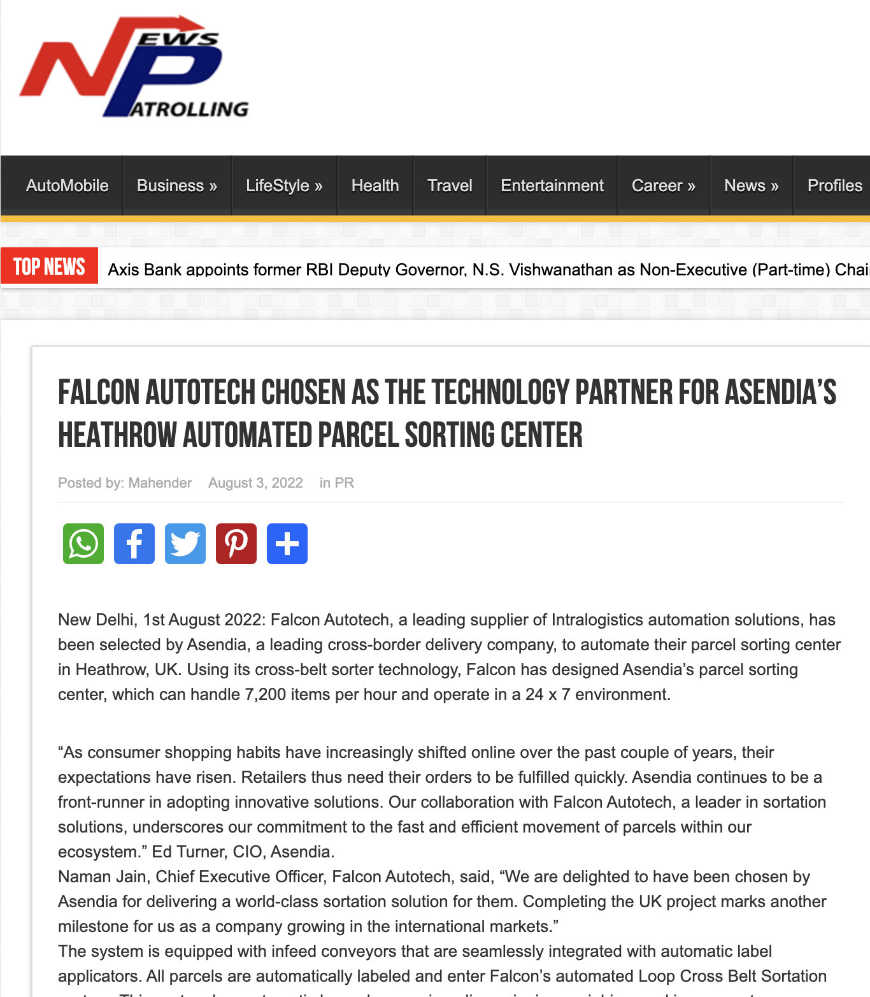

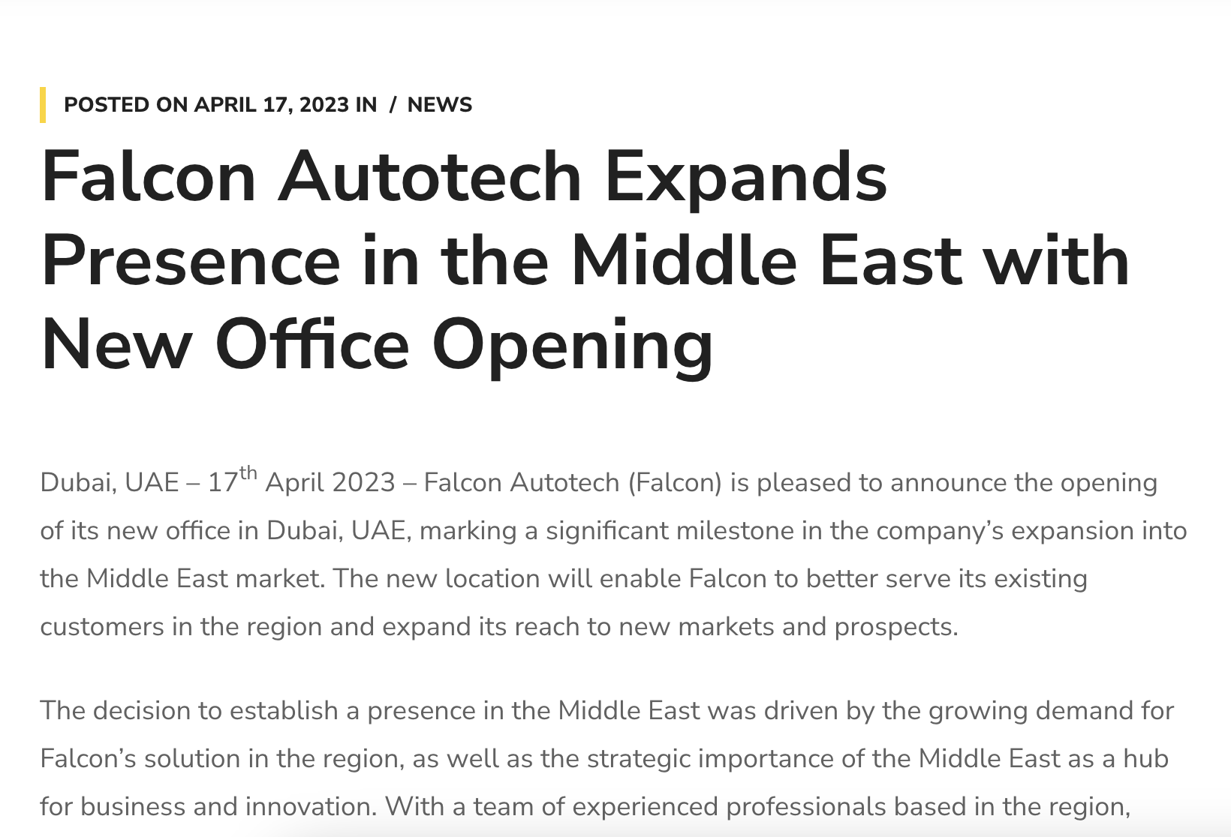



Reference Projects
Falcon has a strong legacy in Warehousing Automation solutions and references-

- Expertise in Shipment Sortation, Piece Picking and Handling, Case Picking and Handling.
- Lifecycle services (maintenance, spares supply chain, support).
- Full in-house expertise (Hardware/Software).
- Turn-key tailored solutions.
The references list presented below focuses on Sortation Solution –

Project 1- (CEP Festo, India)
The System is equipped with two fully automated and interconnected Sub-systems. Sub-System 1 is designed for handling large B2B boxes and E-commerce shipment bags while the Sub-System 2 is designed to handle Small E-commerce packages.
Solution Specifications –
  - 48,000 PPH (Double Deck CBS- Shipment Sorter)
  - 17,000 PPH (Double Deck CBS- Bag Sorter)
- Building Size: 700,000 Sq. Ft
Key Technology Modules –

- 2 Sets of Double Decker CBS Sorters
- Mezzanine Structures (one large mezz on to install a double decker Sorter).
- Automated Singulators
- Fully Automatic Inductions
- Semi-Automatic Inductions
- Telescopic belt conveyors
- PVC Belt Conveyors
- Modular Belt Conveyors
- Spiral Chutes with Braking rollers
- 5-Sided Scanning Tunnels
- High speed weighing conveyors
- Direct Bagging Chutes
- Put to Light Chutes
- Volume Distribution systems
- High Availability Server Systems
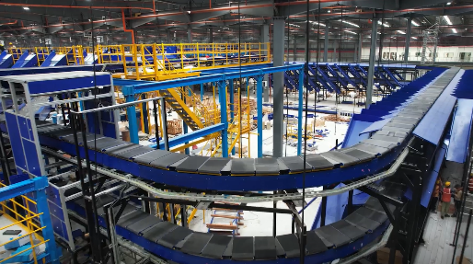
- WCS
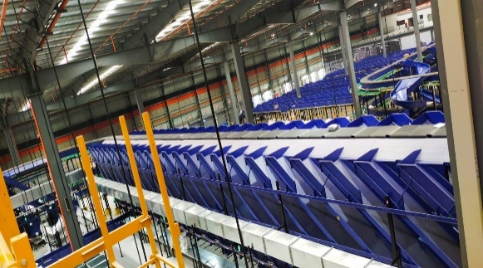
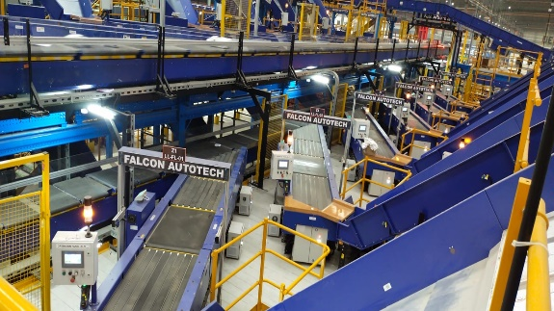
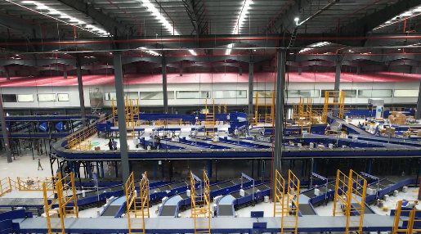
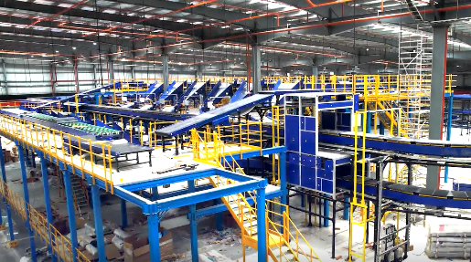

Project 2- (Festo – E-Commerce, India)
Use Case – Destination Sorting of Packed Shipments.
In 2019, Festo was looking for a potential automation partner for design and development of a new automated sortation system for B2C shipments. The system should be able to provide maximum uptime with reduced dependency on skilled manpower, and space optimization.
The customer chose Falcon Autotech based on its unique design which could cater to all their pain points, capability of seamless integration with WMS and life cycle support services.
Solution Specifications –
- Throughput: 27,600 PPH
- End Destinations: 410 Direct Outputs
- Building Size: 200,000 Sq Ft
Key Technology Modules –

- Bulk Infeed Conveyors.
- ARB based Volume Distribution System
- Integrated Presort System.
- Irregular Ejection System.
- Automatic Induct Lines.
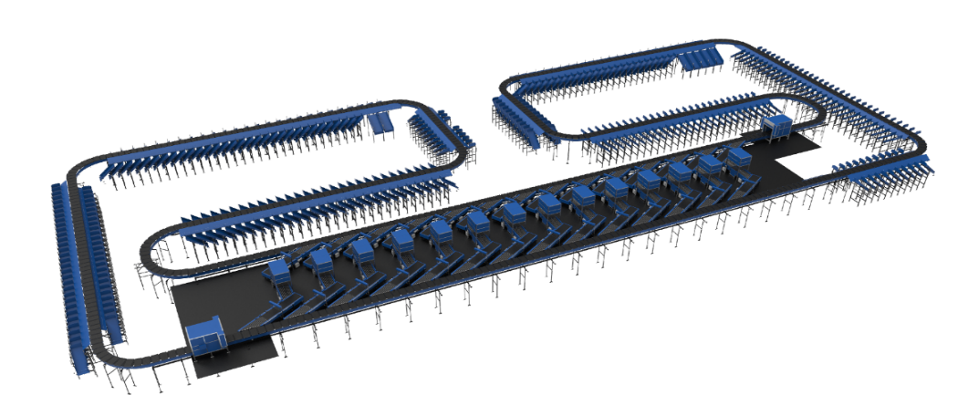
- Automatic Barcode Scanner with Image Capture.
- Automatic Weight & Volume Measurement System.
- Loop Cross Belt Sorter.
- Smart Sliding Chutes for Direct bagging and Cage Sorting.
- Bag take out system
- WCS Software System

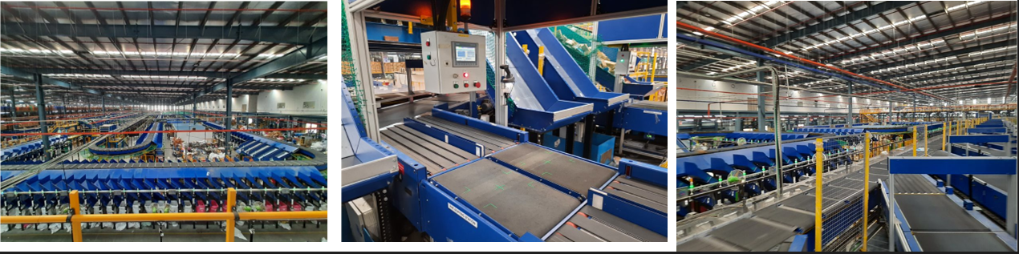

Project 3- (Ecommerce Festo, India)
Use Case - Destination Sorting of Packed Shipments
Solution Specifications –
- Throughput: 24,000 PPH
- End Destinations: 110
- Building Size: 200,000 Sq. Ft
Key Technology Modules - Loop Cross Belt Sorter with a cell size of 900 x 500 mm
Layout and Site Pictures -
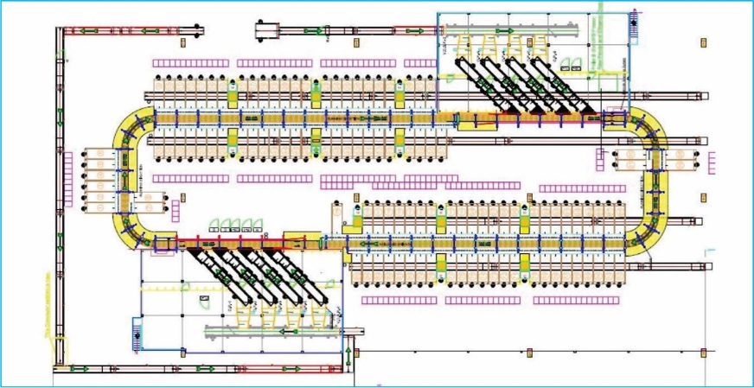

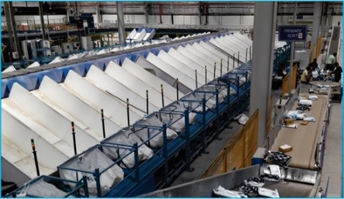
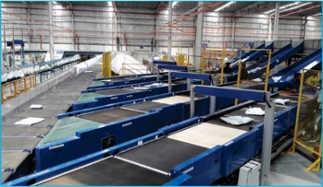

Project 4- (CEP Festo, UK)
This Solution is designed to handle a volume of 7200 shipments per hour. The system is equipped with three infeed conveyors integrated with an automatic label applicator before shipments enter the sortation system. The shipments are sorted using Falcon's Loop Cross Belt Sorter equipped with automatic barcode scanning, dimensioning, weighing and image capture capabilities. The sorter is installed on the mezzanine floor and sorts directly to 58 end destinations.
Solution Specifications –
- Throughput: 7200 PPH
- End Destinations: 58 Nos
Key Technology Modules –
- Powered Belt Conveyors.
- Automatic Induct Lines.
- Automatic Barcode Scanner with Image Capture.
- Automatic Weight & Volume Measurement System.
- Loop Cross Belt Sorter.
- WCS Software System.
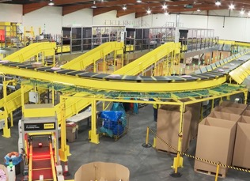
Site Picture –

Project 5- (CEP Festo, Sydney)
Solution is designed for handling a throughput of 16,000 shipments per hour with the help of Falcon’s Loop Cross Belt Sorter. The system consists of 2 feeding zones with a total of 10 feedlines. Sorter design enables the van drivers to directly drop the shipments at the dock doors. It has a total of 369 end destinations that are achieved with a combination of direct drops and PTLs. System is integrated with 5 side automatic barcode scanning, weight and volume measurement and automatic detection of oversize and overweight shipments.
Solution Specifications –
- Throughput: 16000 PPH
- End Destinations: 369 Nos
Key Technology Modules –
- Powered Belt Conveyors.
- 2 Induct zone.
- 5 side Automatic Barcode Scanner.
- Automatic Weight & Volume Measurement System.
- Automatic detection of oversize shipment.
- Loop Cross Belt Sorter.
- WCS Software System.
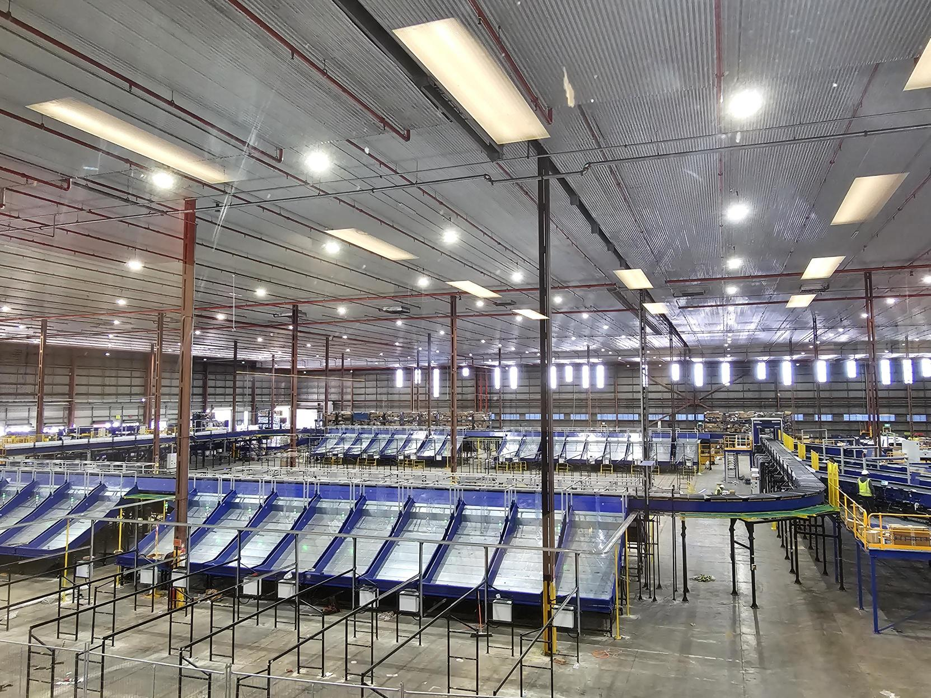
Site Picture –

About Falcon
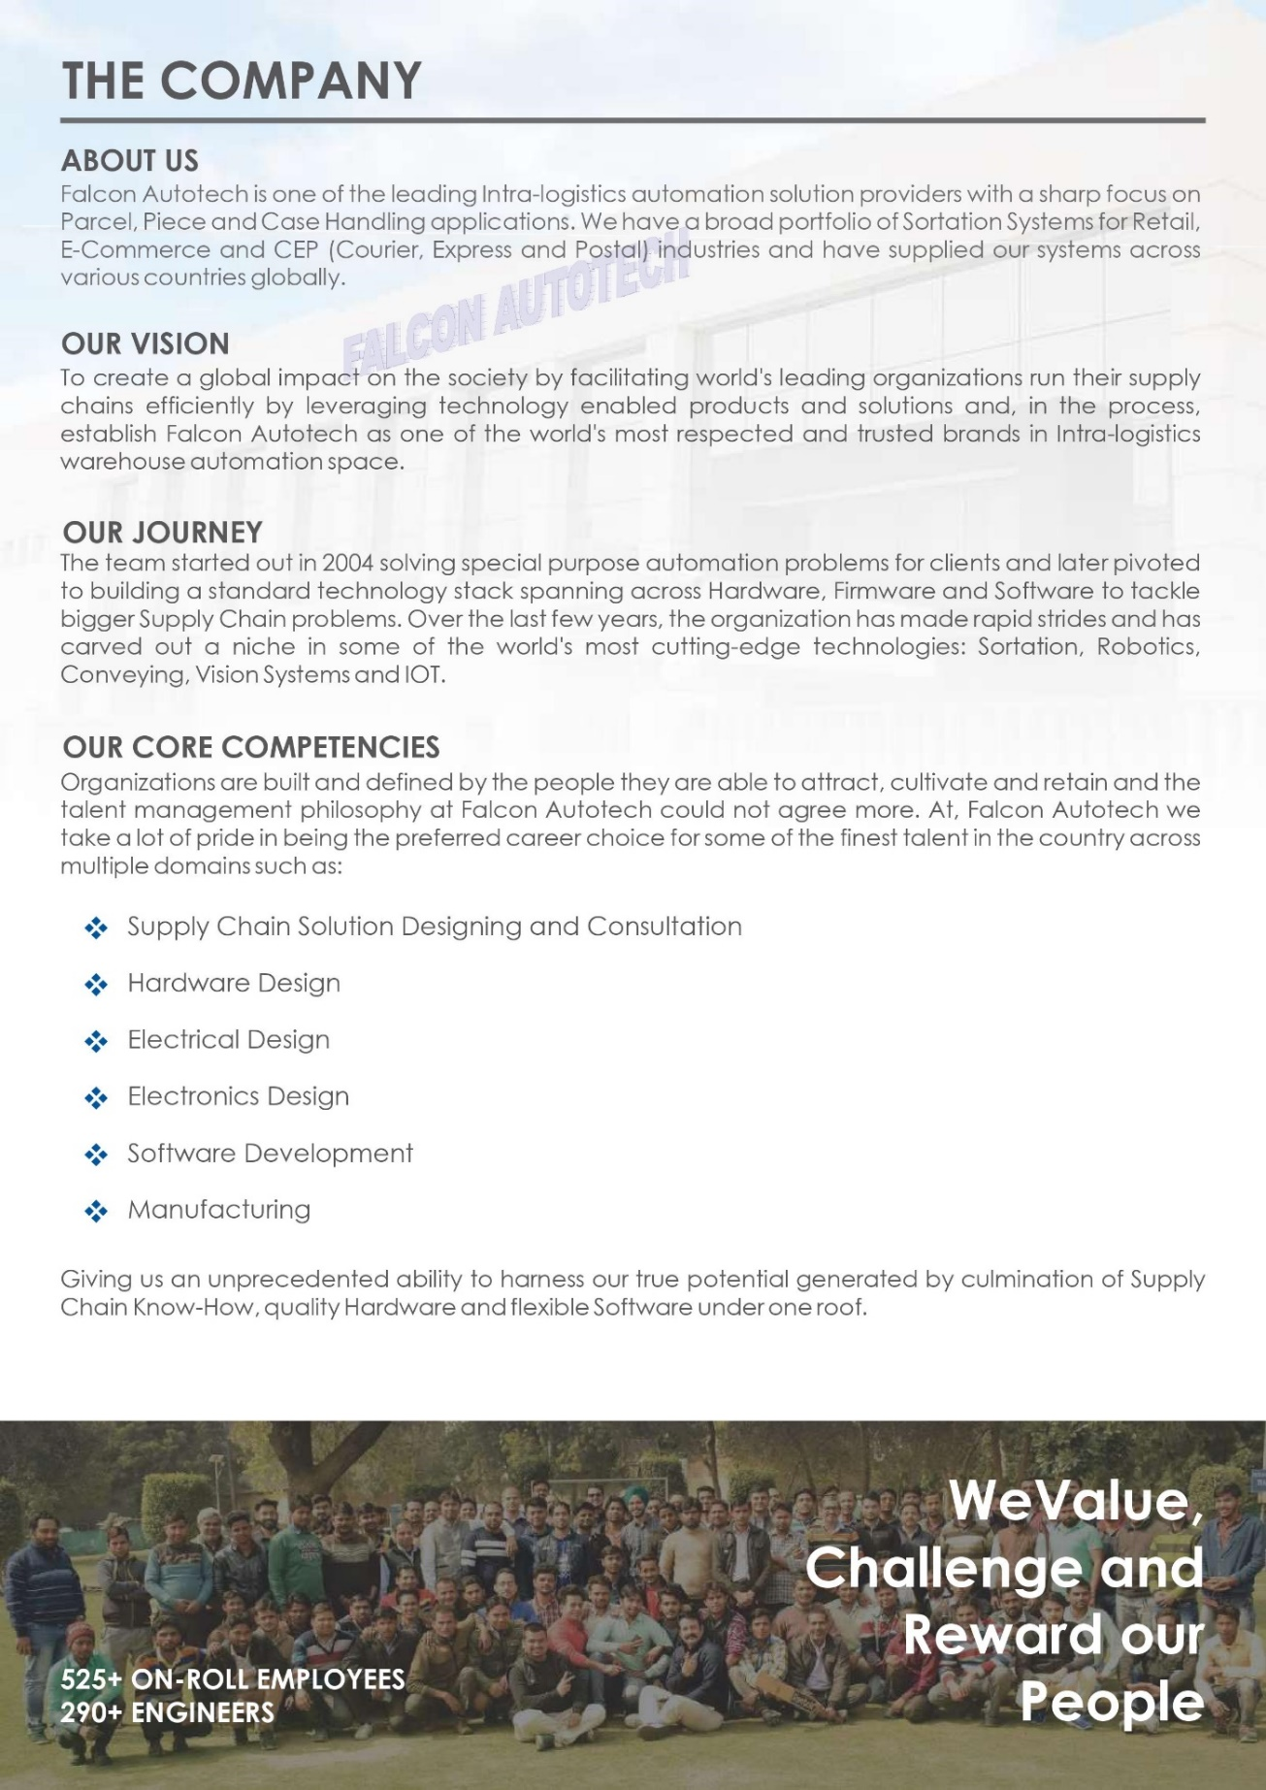
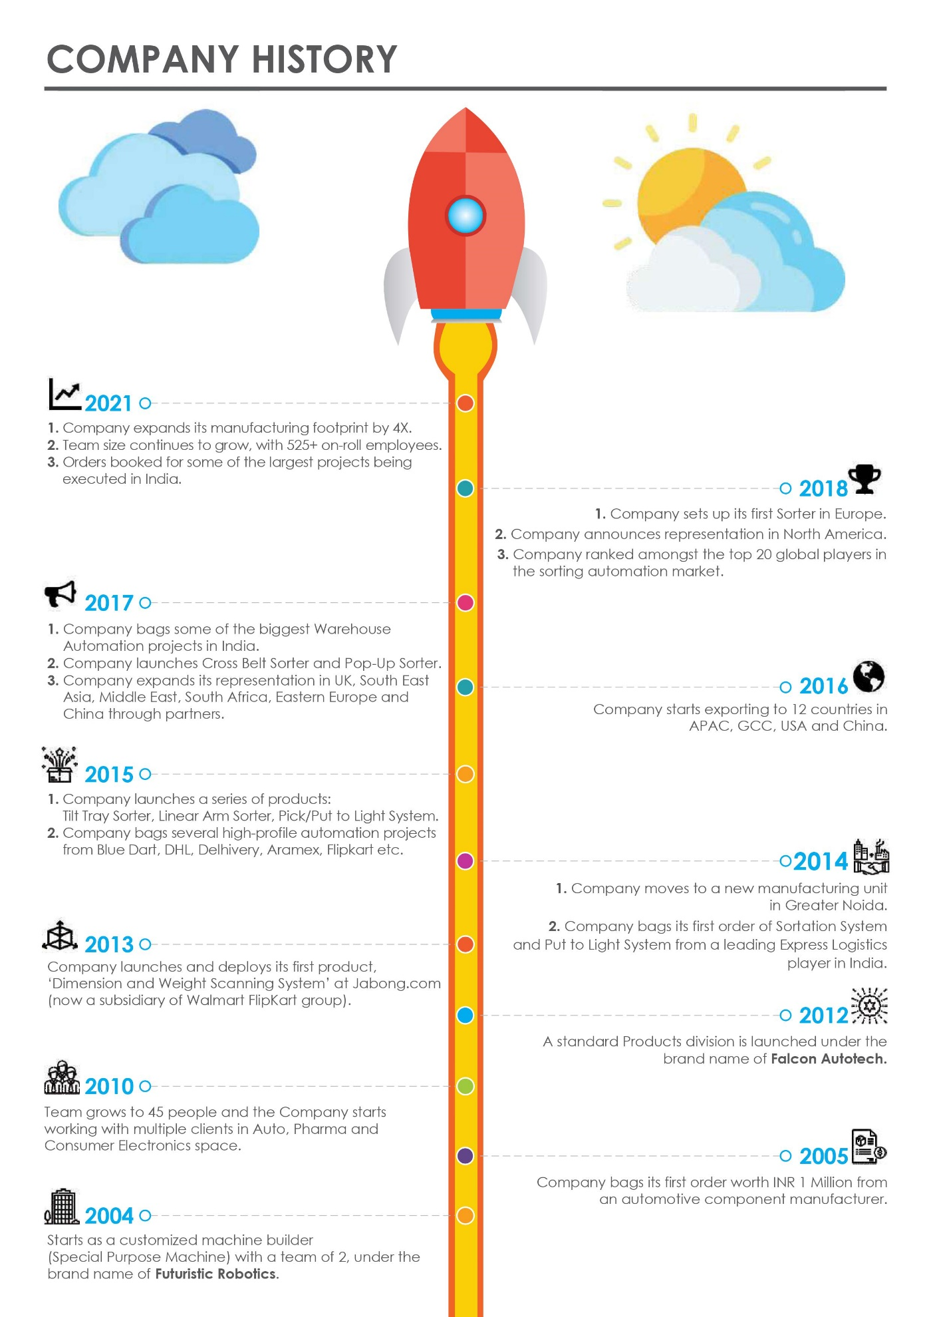
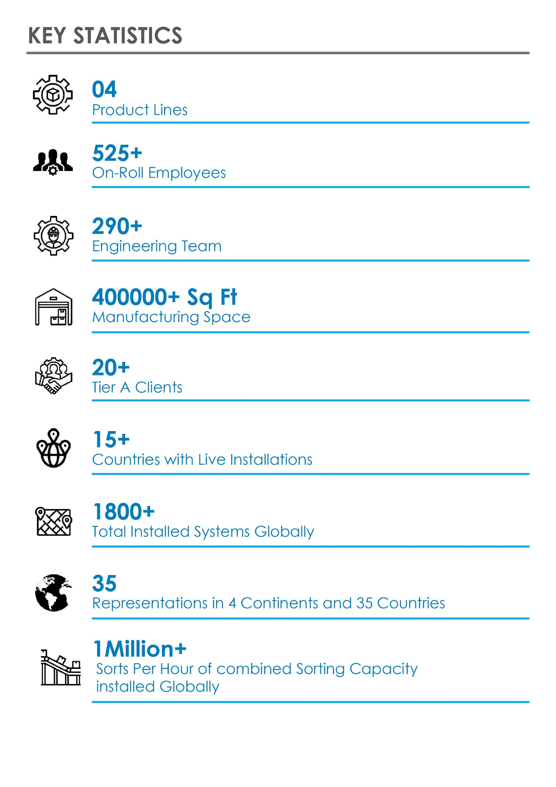
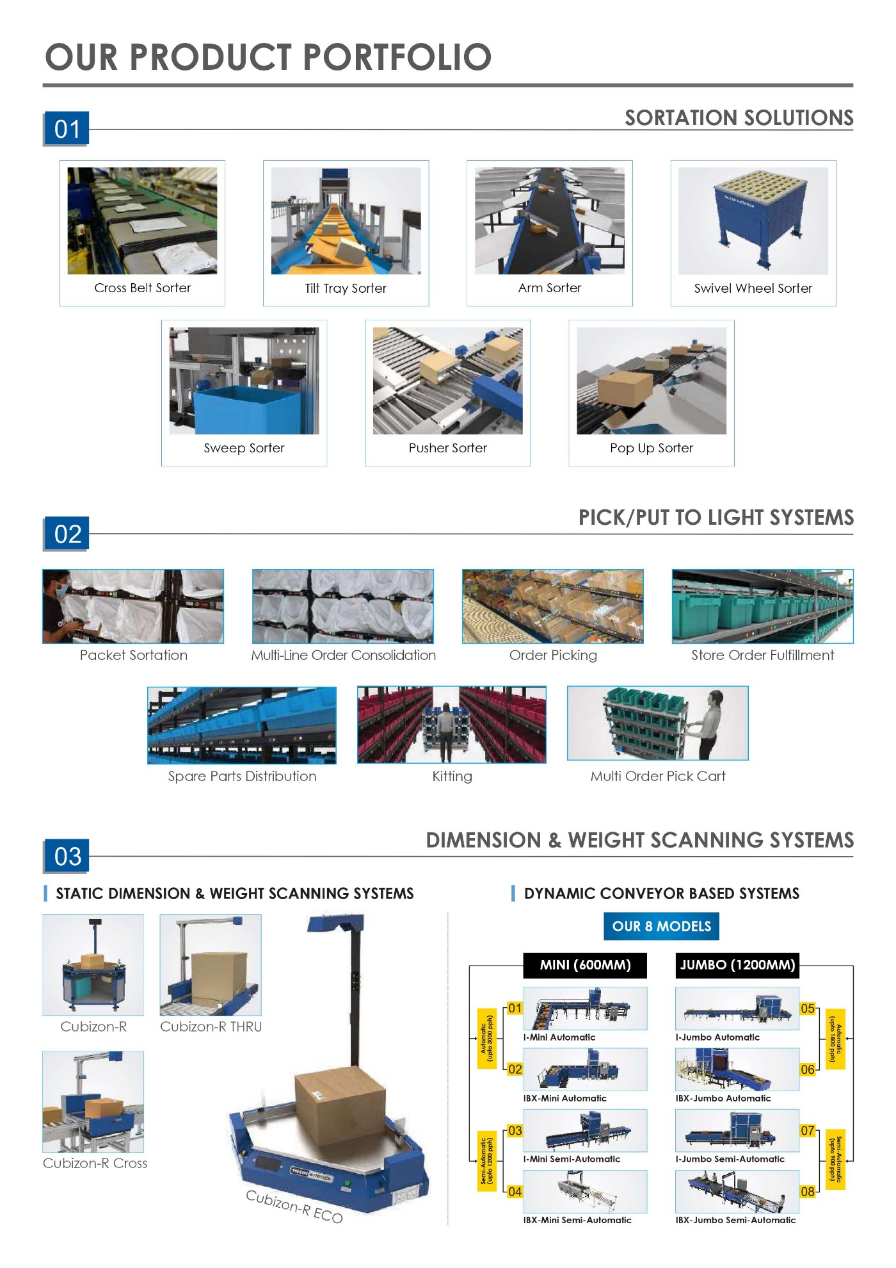
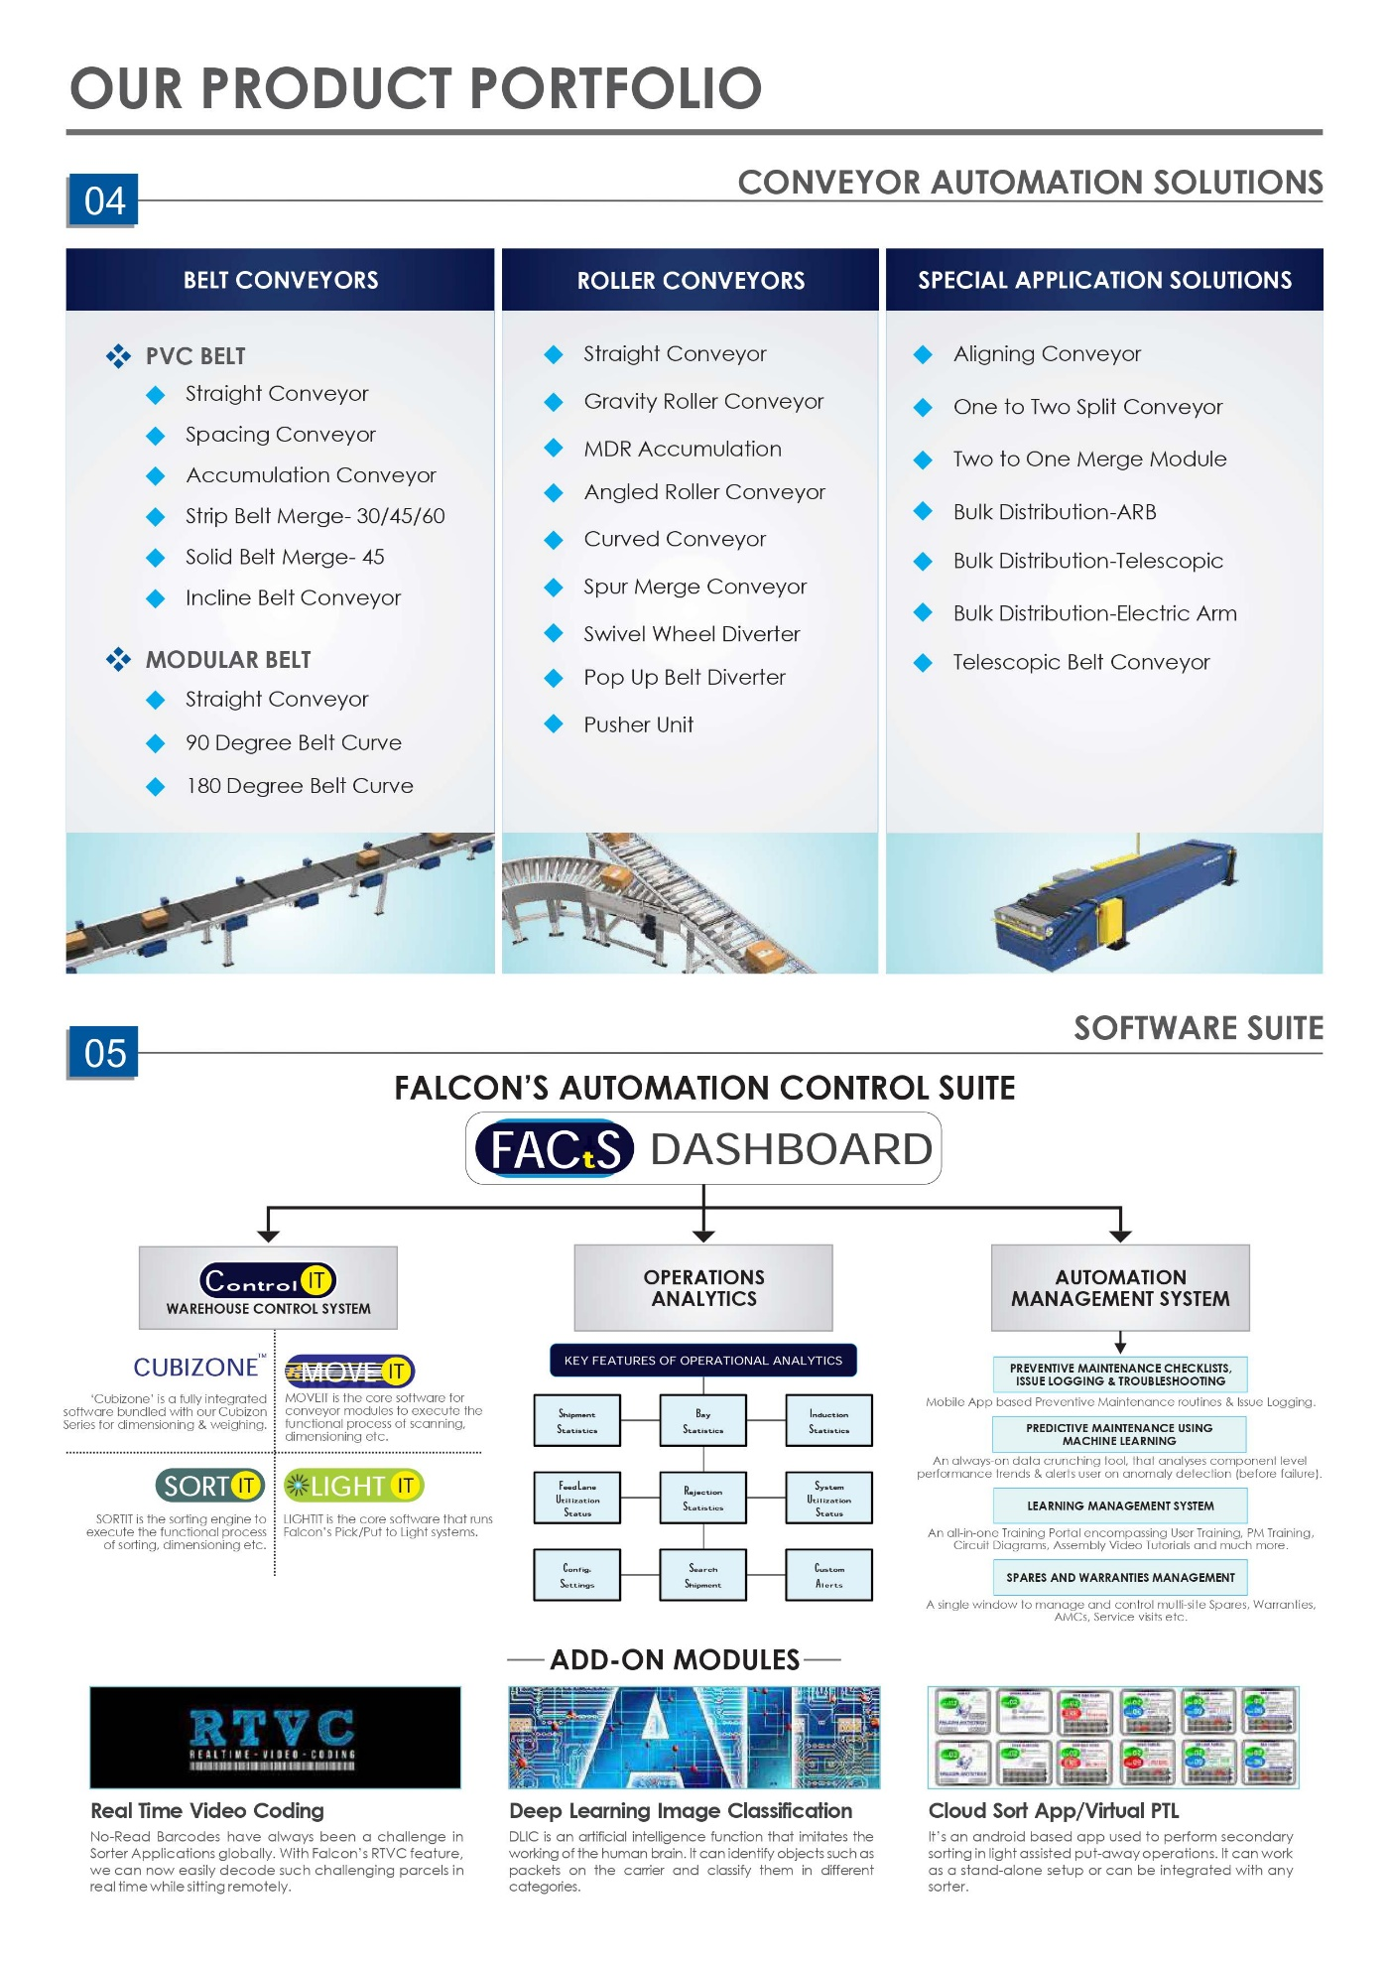
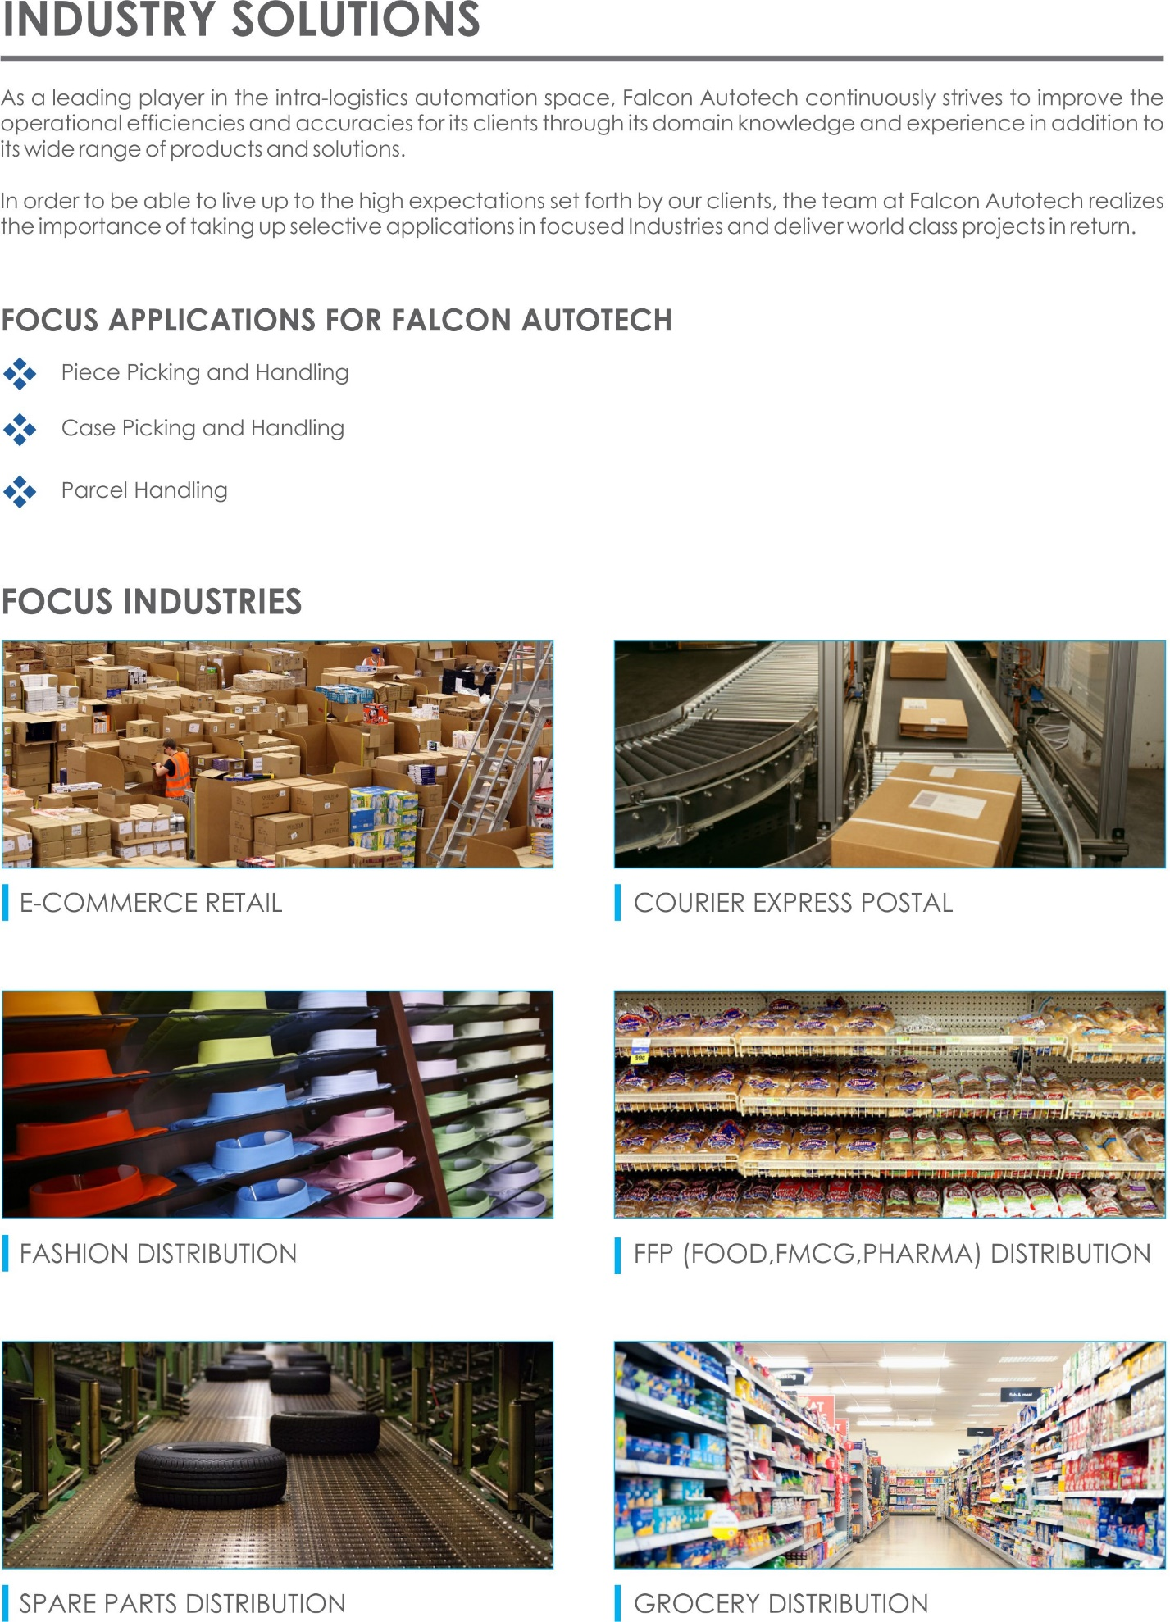
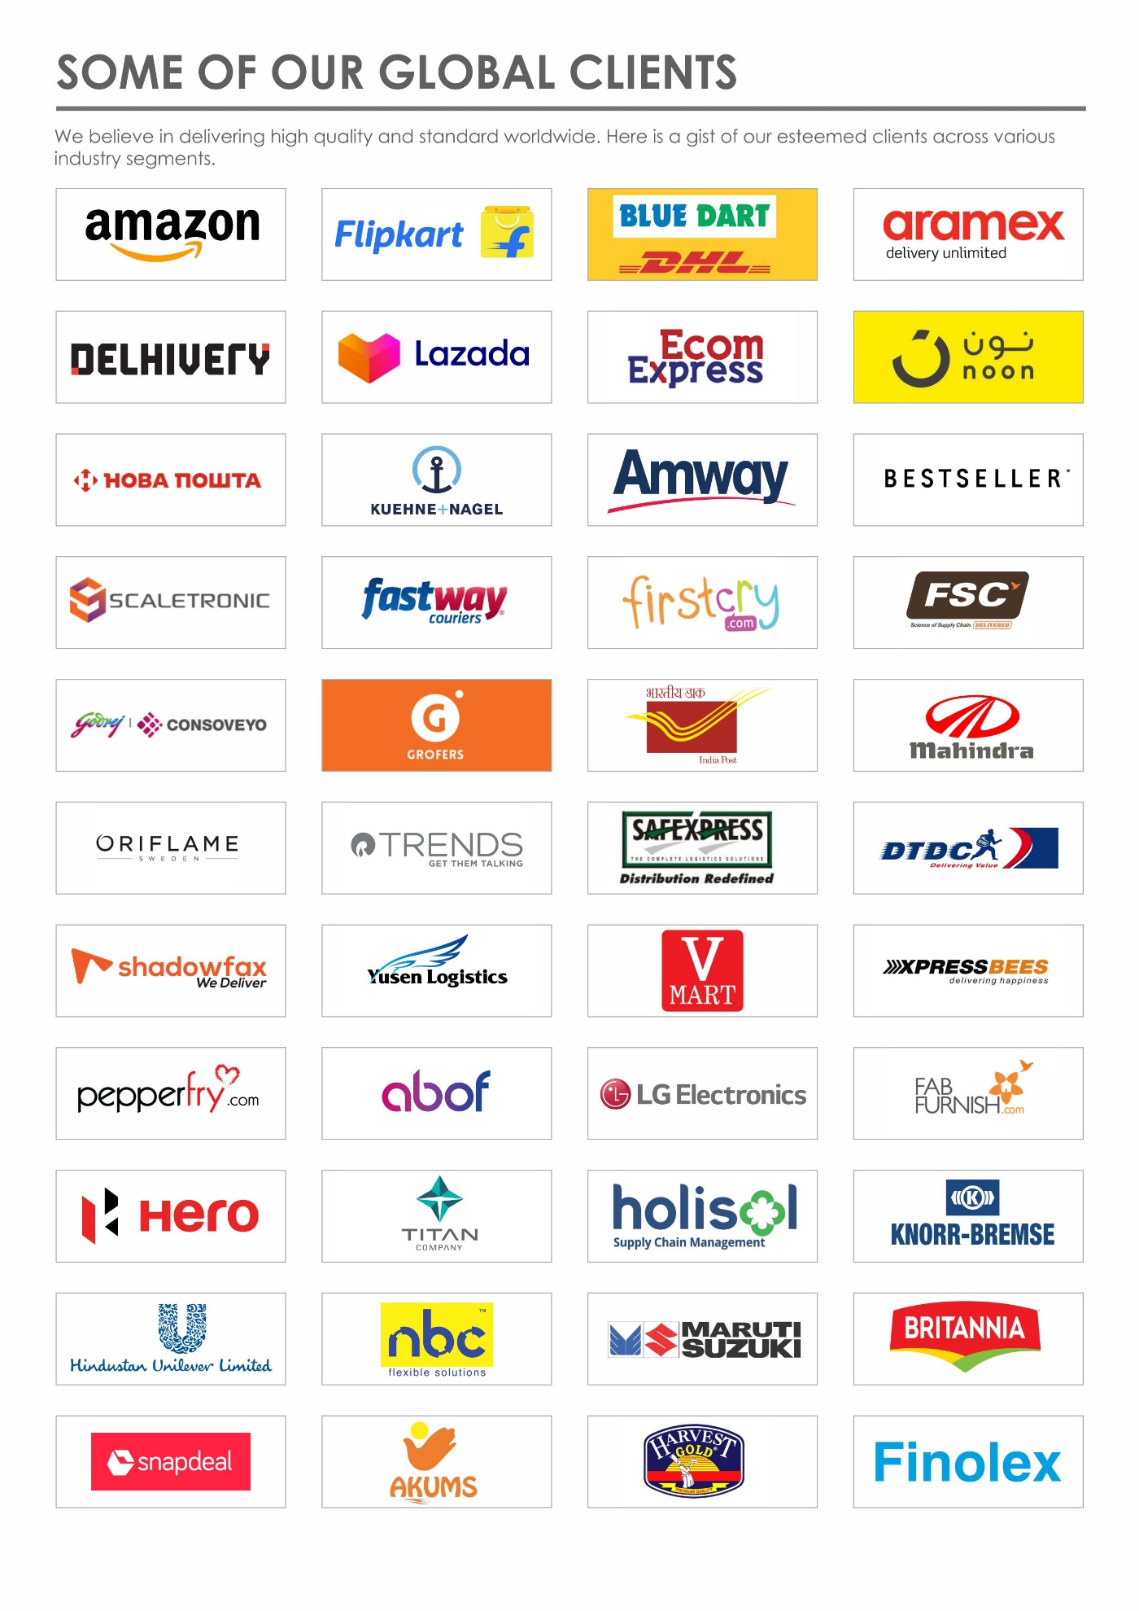

Handled Parcel Spectrumions Minimum Maximum

Product size Conveyable on the entire system.

Max Length | mm | 810
Max Width | mm | 665
Max Height | mm | 420
Max Weight | Kg | 40
Min length | mm | 210
Min Width | mm | 145
Min Height | mm | 75
Min Weight | Kg | 2

Parcels to be loaded on Conveyor/Sorter shall have the following characteristics:

- Centre of Gravity of items must not move during conveyance or sorting.
- Item must not have magnetic content; otherwise behaviour of parcel cannot be guaranteed.
- Liquid or fragile material, to avoid breaking, spillage or leakage, such as wine bottles, metal cans of paint are designated as non- conveyable items.
- Parcels shall be perfectly and safely packaged: protrusion or open surfaces are not allowed.
- Plastic ropes shall be perfectly adherent to the surface of the package.
- All items with the risk of being damaged during the transport on an automatic conveying/sorting system or damaging the system. They must be robust enough to avoid disintegration of container material and loose of contents in the conveying/sorting process.
- Item packaging shall have enough grip to be handled on the belts during the acceleration and
referencing phases.
- Items shall not have slippery surfaces and must be able to withstand acceleration of the items on the belt during the start-stop phases (accelerations up to 0.5 g shall be assured without any sliding or tumbling of the items on the belt conveyor).
- The parcels must have at least one flat and regular surface providing enough stability during conveyance.
- All shapes are permitted except spherical, cylindrical, or alike unstable items & shapes.
- All usual packaging materials are permitted (including paper, carton, plastics, plastic foil, rope, tape, textile, and wood)

Parcel not loadable on the system
All products that are not within the range as described here, are considered non- conveyable products, and must be taken out of the main sorter flow by the operators.

- Unstable items with a risk to roll or tumble on the sorting system, such as spherical or cylindrical items
- Items that have a spherical or cylindrical shape.
- Items that are packed in material that can damage the conveyors or the sorter.
- Items that have sharp points (e.g. Nails) or sharp edges, that can damage the conveyors or the sorter.
- Fragile parcels with contents not sufficiently secured
- Items that have been classified as dangerous are designated.
- Wet items are designated.
- Items with anti-slip treatment.
- Items with protruding parts.
- Items with sharp edges.
- Inadequately packed items that could be damaged during automatic transportation.
- Electrostatically loaded items.
- Loose parts on loads and load carriers, such as adhesive tape, stickers, slips of paper, straps, wrap foil etc. are designated as non- conveyable items.

Types of Products
Parcel Type | Description
Cartons | Types of Carton  Min: L-210 X W-145 X H-75 MM  Max: L-810 X W-665 X H-420 MM

Proposed System Description

Objective
The purpose of this proposal is to present the design, manufacturing, installation, commissioning, testing and acceptance testing of the complete automation system to handle Cartons as per specifications shared by Festo.
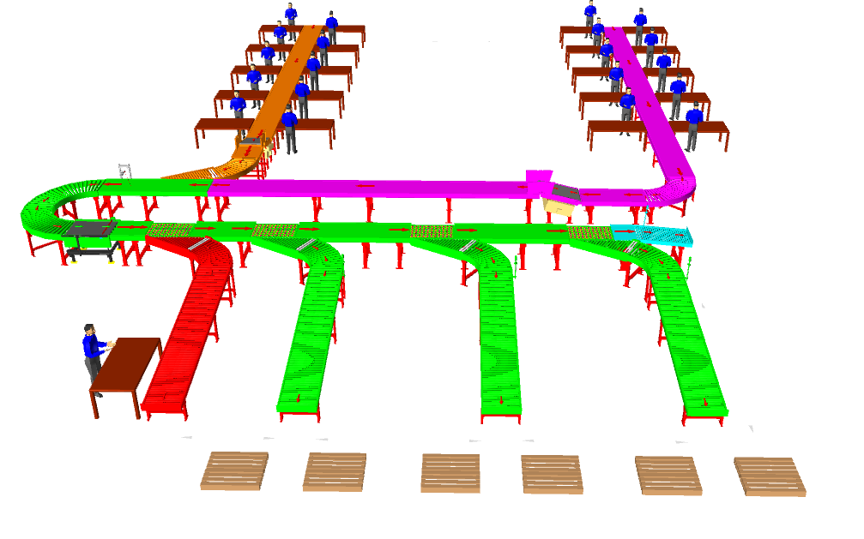

Summary of the System
- Infeed: SKU Cartons are fed into the system through 2 Nos Infeed lines running throughout the packing table area.

- Outbound Sorter: Cartons are sorted Cross Dock and Beat wise through SWEDI Diverter into three main aisles.

- Provision for rejection line for inspection & rework is given separately.

- Distance b/w Scanner and Divert units is kept considering communication through PLC. (Stackbox to ensure WCS to have required data on regular basis)

Main benefits of the proposed solution
The proposed solution has the following advantages:
- High operational throughput
- Maximized sorting capacity throughout at dispatch sorter to meet the requirement.
- Low occupancy of floor space in the building
- FALCON’s system can adapt with changing business requirements by adjusting its speed to match the operational throughput requirement, thereby leading to Power Savings and reduced system Wear & Tear

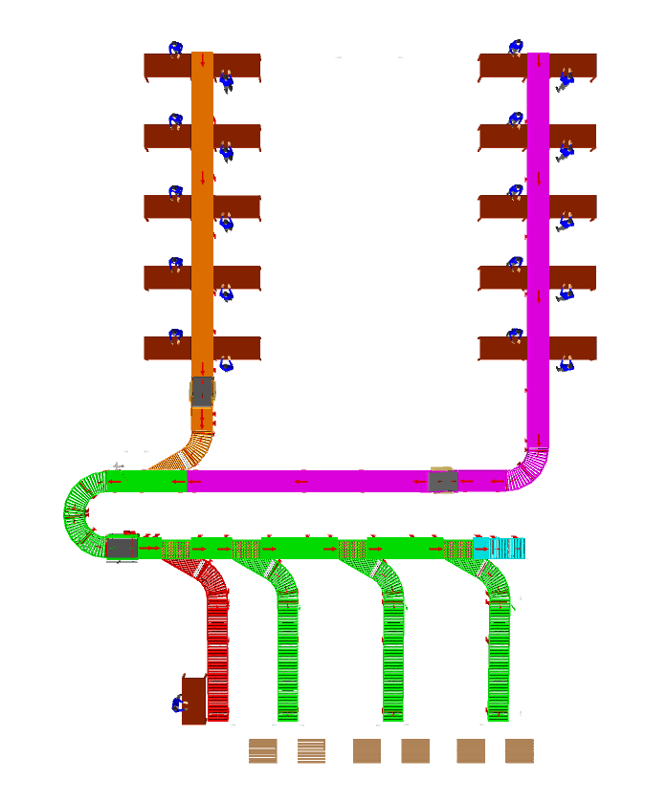
Layout View

1
1

2
2

4
3
5

Legend
1 – Packing Table
2 – Infeed loading line
3 – Highway line
4 – Side Barcode Scanner
5 – Outbound Sorter

Proposed System Capacity

System Capacity at various areas
Activity | Cartons per hour
Infeed Lines and Loop | 1000+1000
Outbound Sorter | 2000

System description

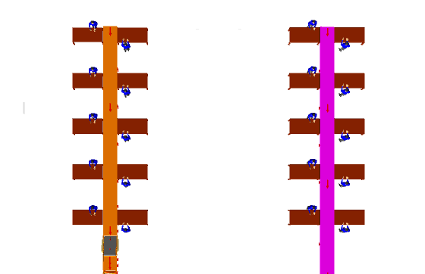
Infeed Lines and Loop

2
1
1
2

Legend
1 – Packing Tables
2 – Infeed Line

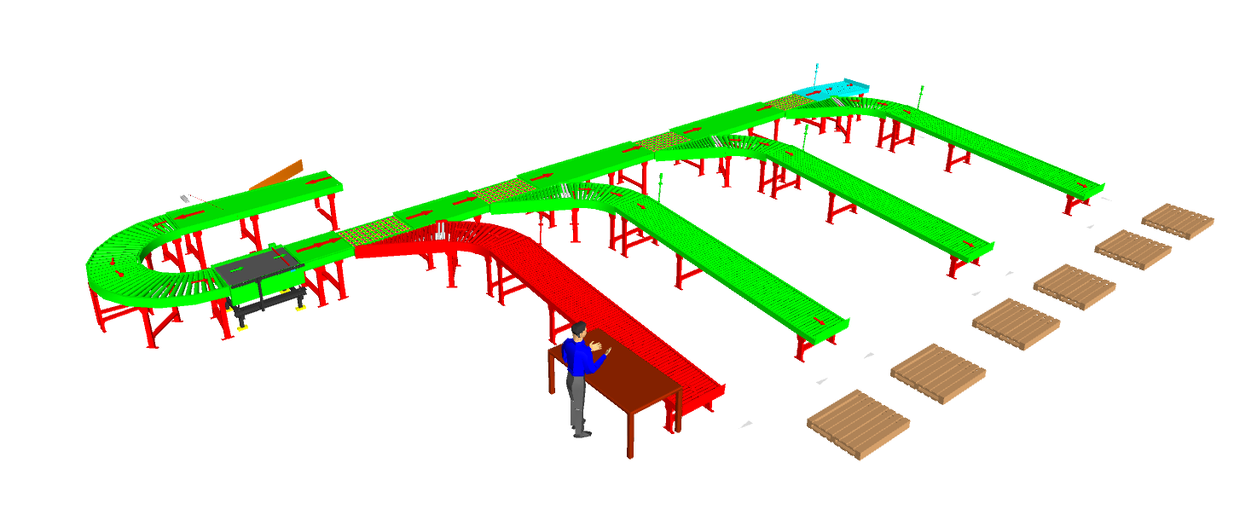
Outbound Sorter
5
3
3
3
2
3
1

4

Legend
1 – Highway Line
2 – Barcode Scanner
3 – SWEDI Units
4 – Rework Line
5 – Sortfail Line

System Components

Powered Roller Conveyor
Falcon’s Roller conveyors are highly energy efficient and require negligible maintenance leading to very minimal Operating costs and thus lower cost of ownership.
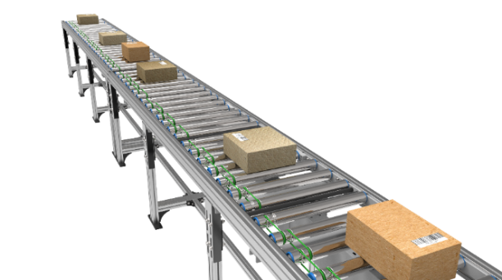
Some Salient Features of Falcon’s roller conveyor:
- Low Noise
- Maximum uptime.
- Minimal maintenance
- High safety standards.
- Fastest ROI
- Comes with MS frame.

Specification | UOM | Remark
Manufacturer Name | Name | Falcon Autotech
Material of Roller | Type | MS Rollers with Zinc Plating
Overall Width | mm | 800
Conveyor Height | mm | Variable as per design shared
Drive Power Rating | Watt | 40
Type of Motor | Type | DC Rollers (MDR)
Ingress Protection | Type | IP 54
Type of Drive System | Type | Poly V Belt Drive
Insulation Class | Type | Yes
Conveyor Speed | m/s | Variable speed to meet TPH requirements
Load capacity/unit length of Conveyor | kg/m | 50
Roller Span | mm | Variable
Roller Diameter | mm | 50
Pitch of Rollers | mm | 75/100
Type of Mounts | Type | Fixed Heights Legs with required Grouting Provisions

Accumulation Conveyor
Falcon’s Accumulation conveyors are highly energy efficient and require negligible maintenance leading to very minimal Operating costs and thus lower cost of ownership.
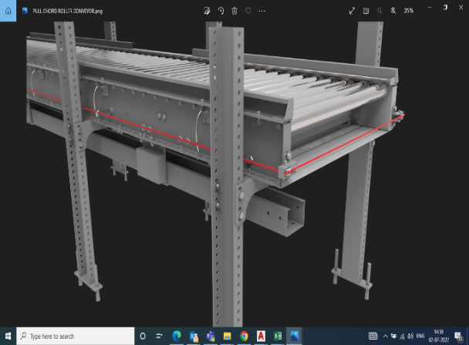
Some Salient Features of Falcon’s accumulation conveyor:
- Low Noise
- Maximum uptime.
- High safety standards.
- Fastest ROI
- Comes with MS frame.

Specification | UOM | Remark
Manufacturer Name | Name | Falcon Autotech
Material of Roller | Type | MS Rollers with Zinc Plating
Overall Width | Mm | 800
Conveyor Height | Mm | As per Layout requirement
Drive Power Rating | Watt | 40
Type of Motor | Type | DC Rollers (MDR)
Ingress Protection | Type | IP 54
Type of Drive System | Type | Round/Poly V Belt Drive
Insulation Class | Type | Yes
Conveyor Speed | m/s | Variable speed to meet TPH requirements
Load capacity per unit length of Conveyor | kg/m | 50
Roller Span | Mm | Approx. 600
Roller Diameter | Mm | Approx. 50
Pitch of Rollers | Mm | 75
Zone Length | Mm | 825
Type of Mounts | Type | Fixed Heights Legs with Grouting Provisions
Type of Guides | Type | Steel guides at 50mm height basis the position of conveyor on both sides from Conveyor Belt Surface.

PVC Belt Conveyor
Falcon’s Belt Conveyors are modular & robust in design. MS profile is used to build conveyor frame.
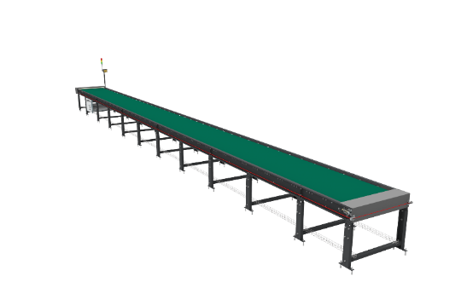
Some Salient Features of Falcon’s Belt conveyor:
- Low Noise
- Maximum uptime.
- Minimal maintenance
- High safety standards.
- Fastest ROI.

Specification | UOM | Remark
Manufacturer Name | Name | Falcon Autotech
Material of Roller | Type | MS Rollers with Zinc Plating
MOC of Belt | Type | PVC
Belt Thickness | mm | 3
Belt Finish | Type | Matt Finish
Belt width | mm | 800
Belt Joint Type | Type | Vulcanized, Endless Belts
Belt Make/Model No. | Make | FORBO/DERCO
Chassis | mm | MS, 3mm Thick, Powder Coated-75 Microns
Idler Roller Pitch on running side (Top) | mm | 480
Idler Roller Pitch on return side (Bottom) | mm | 1200
Idler Roller Specs | Spec | Dia.50.8, shaft-12 mm, bearing-6301
End Rollers | Spec | Dia 81.2 x 2.85 Thick, 30mm Shaft Dia, & Bearing Size-UCFH206D1, MOC-EN9, Zinc Plated -25 microns
Drive Rollers | Spec | OUTER Dia 178 PIPE Dia 168x5 Thick, 40mm Shaft Dia, & Bearing Size-UCF208D1, MOC(SHAFT)-EN9, NEOPRENE RUBBER COATING
Tensioning Rollers | Spec | Dia 81.2 x 2.85 Thick, 25mm Shaft Dia, & Bearing Size-UCT205D1, MOC-MS, Zinc Plated -25 microns
Type of Drive | Type | Rubberized
Angle of wrap/Contact - Belt with Drive pulley | Deg | >180 deg
Motor Shaft | MOC | EN9 Shaft material,
Load capacity per unit length of Conveyor | kg/m | 50
Drive Power Rating | kW | Motor Rating depends on Length of the Conveyor
Type of Motor | Type | AC Geared Motor
Ingress Protection | Type | IP 55
Type of Drive System | Type | Direct Shaft Mounted Motor/ Flange Mounted
Type of Drive | Type | Chain drive/Torque Arm type
Gear Motor | make | Sew/Nord
Drive | make | Lenze/Siemens/Omron/Allen Bradly
Insulation Class | Type | Yes
Conveyor Speed | m/s | Variable speed to meet TPH requirements
Type of Mounts | Type | Fixed Heights Legs with Grouting Provisions

Powered Roller Turns & Merges
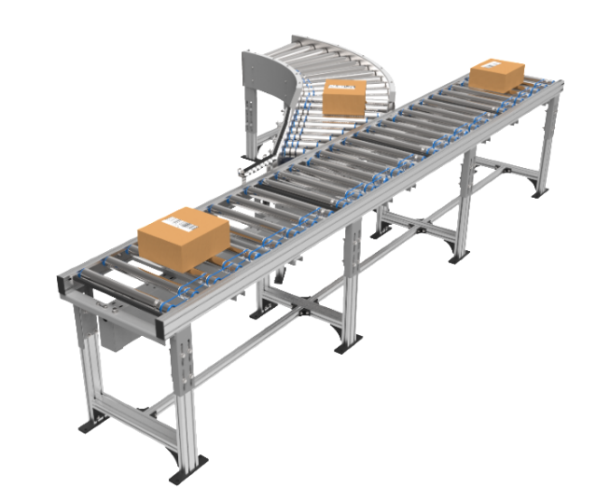
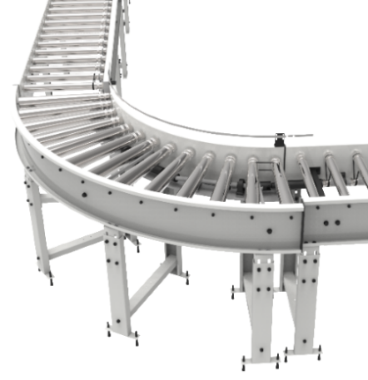

Side Barcode Scanners
System is integrated with automated inline side barcode scanning system capable for scanning 1D barcodes with high accuracy.
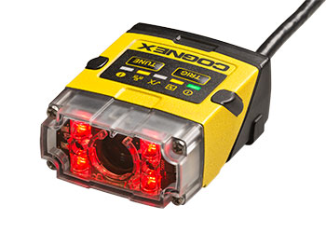
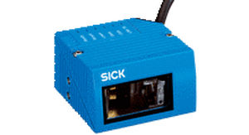

Specification | UOM | Remark
Manufacturer Name | Name | Cognex/Sick
Barcode Type | Type | 1D
Location | Side | Left
Orientation | Type | Omnidirectional
Color of bars | Color | Black
Under Foil | yes/no | No

Swivel Wheel Sorting Unit – Falcon
Falcon’s Swivel wheel divert is used in system for the smooth transfer of products.
Some Salient Features of Falcon’s Swivel Wheel Divert:
- Low Noise
- Maximum uptime.
- Electric based rotation of wheels.
- Minimal maintenance
- High safety standards.
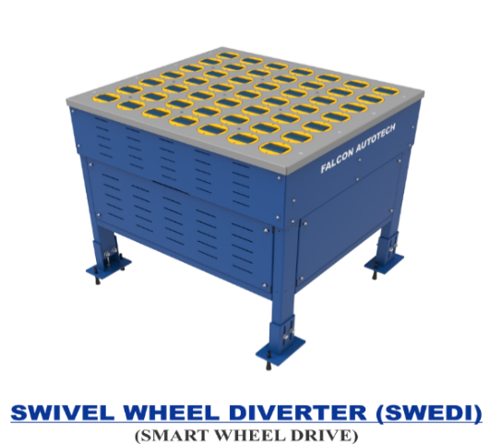

Specification | UOM | Remark
Manufacturer Name | Name | Falcon Autotech
Type - Equipment | Type | Merge/Sorting
Type - Operation | Type | Sorting
Mechanism for Swivel | Type | Electric servo motor
Roller drive | kW | Powered smart wheel
Roller pitch (L x W) | Type | 110 x 120
No. of divert sections | Yes/No | 1 or 2
Max. product weight (kg/m2) | kg/m2 | 25
Throughput | PPH | 2000
Type of Mounts | Type | Fixed Heights Legs with Grouting Provisions

Proposed System Technical Details/BOM

Mechanical equipment
Pos. | Qty. | Description | Value
1 | 1 | Infeed System  - PVC Belt Conveyor  - Accumulation Roller Conveyor  - 60 deg turns  - Angle Merge | ~1.2 metres (01 Modules)  ~ 14.8 metres (02 Modules)  01 Nos  01 Nos
2 | 1 | SWEDI Sorter  - Powered Roller Conveyor  - Gravity Roller Conveyor  - 60 deg turns  - 90 deg turns  - Angle Merge  - SWEDI Unit  - Side Barcode Scanner  - Spacing Conveyor | ~13.2 meters (06 modules)  ~22.7 meters (05 modules)  04 Nos  02 Nos  04 Nos  04 Nos  01 Nos  01 Nos
3 | 1 | Future Expansion  - PVC Belt Conveyor  - Accumulation Roller Conveyor  - 90 deg turns | ~1.2 metres (01 Modules)  ~ 29 metres (03 Modules)  01 Nos

Electrical Equipment

Electricals
1 | 1 | Consists of  Main Power Distribution panel  Main Control Panel  Network Switches  Field Cabling | Included

Control System

Components
1 | 1 | Consists of  Siemen’s PLC based Control System with Industrial Switch | 1 Nos.  As per requirement

High Availability Server Specifications
S. No | Configuration | Role | Qty | Purpose
1 | Dell PowerEdge T440 (Chassis with up to 8, 3.5" Hot Plug Hard Drives) Tower  Server Trusted Platform Module 1.2 Intel Xeon Silver 4110 2.1Ghz, 8C/16T, 9.6GT/s 2UPI, 11M Cache, Turbo, HT (85W) DDR4-2400 40 GB (2 x 16GB,8 GB) RDIMM 2666MT/s Dual Rank 2 x 1TB SATA 7.2K 3.5" 6Gbps Fully assembled (Hot Plug) Hard Drive PERC H330 Integrated RAID Controller DVD +/-RW, SATA, Internal Single Hot-Plug Redundant Power Supplies (1+0) 495W Dual-Port 1GbE On-Board LOM iDRAC9 Express 3Yrs Basic Warranty - NBD | Node 1 - Prod Server | 1 | Failover Cluster is configured on this system. If this node fails, then the VM shifts from this node to another and vice versa
2 | Dell PowerEdge T440 (Chassis with up to 8, 3.5" Hot Plug Hard Drives) Tower  Server Trusted Platform Module 1.2 Intel Xeon Silver 4110 2.1Ghz, 8C/16T, 9.6GT/s 2UPI, 11M Cache, Turbo, HT (85W) DDR4-2400 40 GB (2 x 16GB, 8 GB) RDIMM 2666MT/s Dual Rank 2 x 1TB SATA 7.2K 3.5" 6Gbps Fully assembled (Hot Plug) Hard Drive PERC H330 Integrated RAID Controller DVD +/-RW, SATA, Internal Single Hot-Plug Redundant Power Supplies (1+0) 495W Dual-Port 1GbE On-Board LOM iDRAC9 Express 3Yrs Basic Warranty - NBD | Node 2 - Prod Server | 1 | Failover Cluster is configured on this system. If this node fails, then the VM shifts from this node to another and vice versa
3 | Intel® Xeon® processor E3-1200 v5 product family, 16 GB RAM, 1 TB * 2HDD, RAID 1, iDRAC8 Enterprise (upgrade), 3 years Onsite warranty. | Domain Server | 1 | Hyper V will work with Domain System So that we required Domain Server Which will manage the nodes
4 | Synology storage with 4 TB HDD | Network Storage Box 1 | 1 | For Creation of Clustered Share Volume, VM will be created on this BOX
5 | Synology storage with 4 TB HDD | Network Storage Box 2 | 1 | Backup & Replication of CSV
6 | Power Backup | Power Backup | 3 | UPS for the Servers & Network Boxes
7 | Monitor - 19.5 inch | Monitor | 1 | Monitor
8 | KVM Switch | Switch | 1 | To switch over the display between servers
9 | Windows Server 2016 Standard R2 or Higher | Windows License | 3 | OS

Falcon’s WCS CONTROLIT
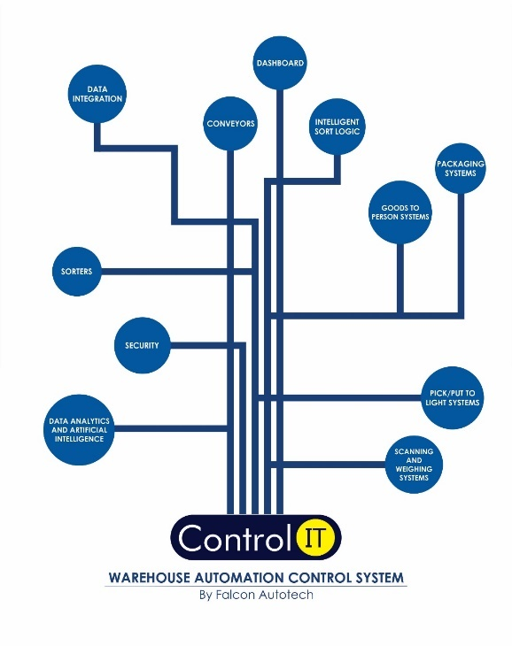
Key Values
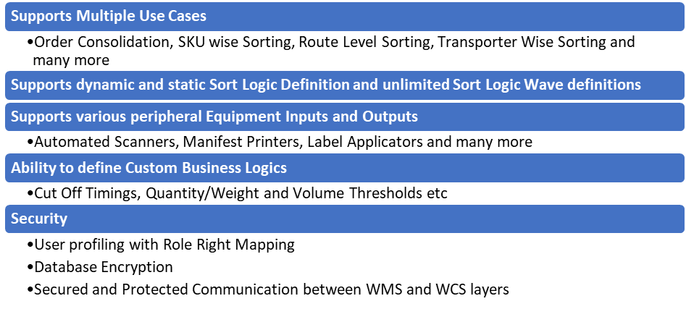
Supported Protocols
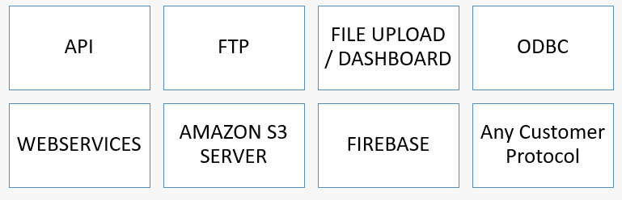

Key Component Makes
Component | Make
PLC & RIO | Siemens/Omron
VFD | Siemens/Omron/Lenze/AB
Ethernet switch | Siemens/Phoenix Contact
SMPS | Omron/Selec/Meanwell
Line chokes | EMIS/GURU NANAK ELE.
Slim relays | Phoenix contact
Terminals | Wago
Phase failure relay | Selec
Tower lamp + Hooter | Leuze
Utility switch & socket | Anchor
Fan/Air conditioner | Rexnord
Switchgear | Schneider
Main load break switch (CP) | Schneider
Geared Motors | SEW
MDR | Pulse
Cameras | Cognex/Sick
Weighing Scale | Mettler Toledo/Bizerba

Safety

Push Buttons
Emergency Push Buttons will be provided at all the points of human interaction on the system.
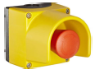

Safety Netting, barricading, Bollards, toe guards or any such safety requirements shall be in Festo Scope. Any other safety requirements requested by Festo will be on chargeable basis.

Automation Management System (AMS)
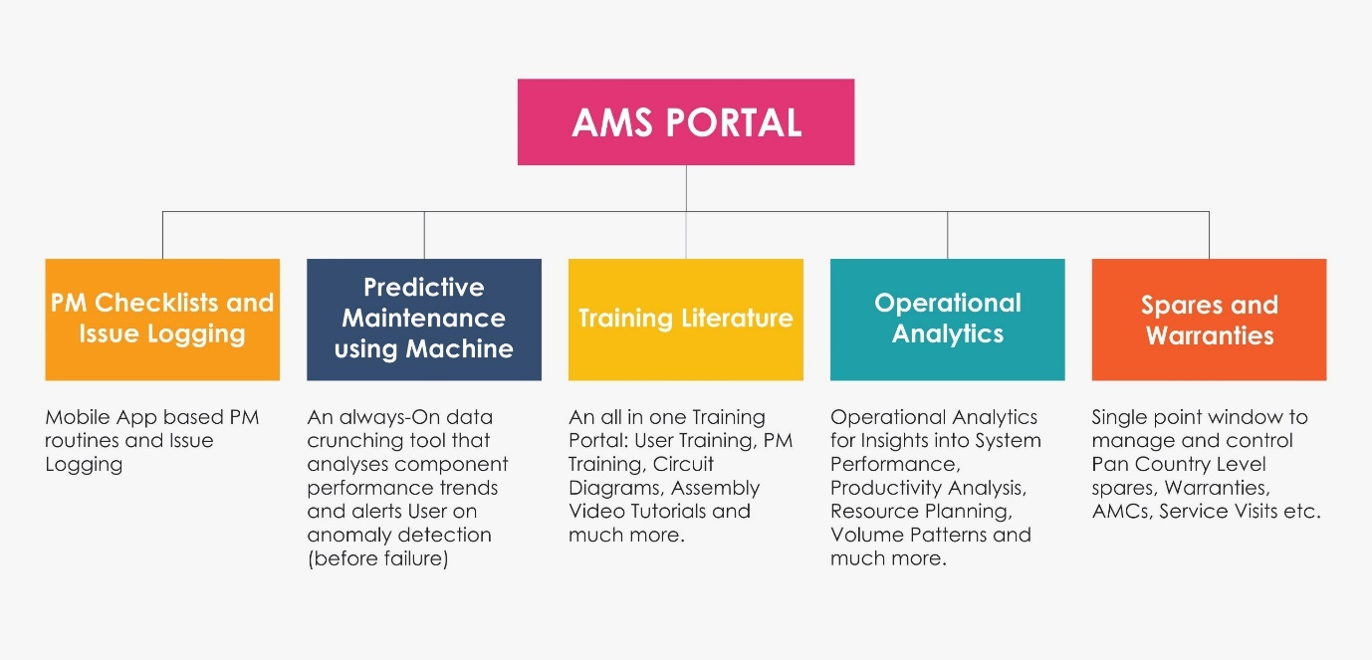

Issue Logging

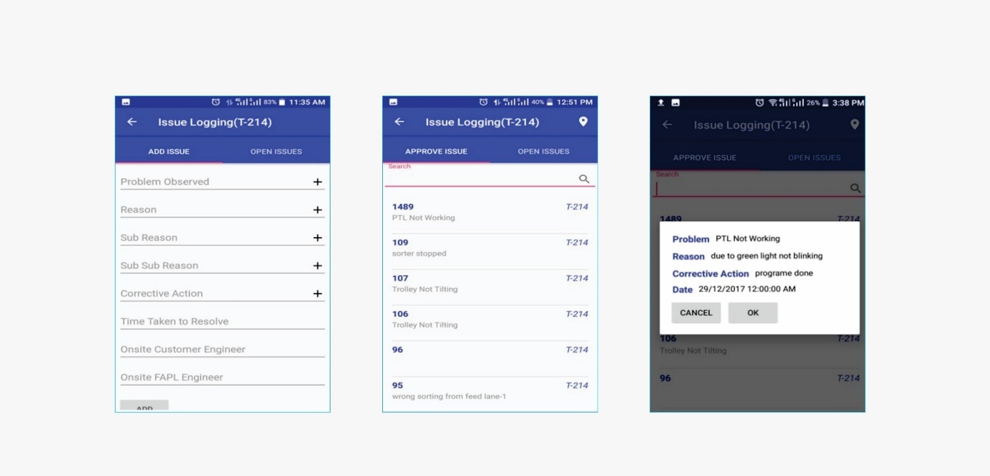

Preventive Maintenance Check List
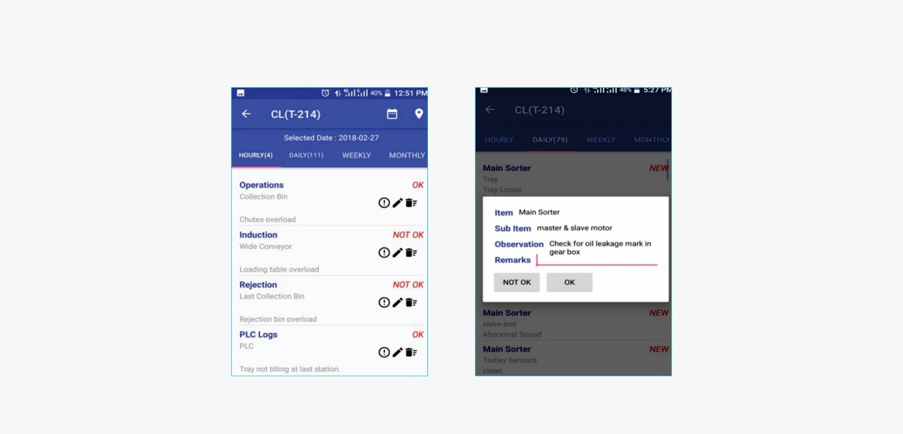

Predictive Maintenance
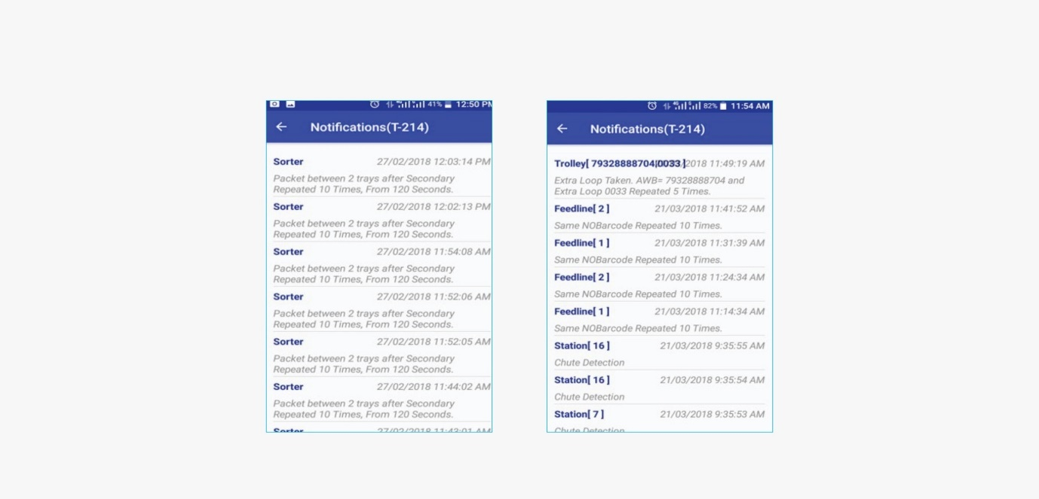

Training Portal
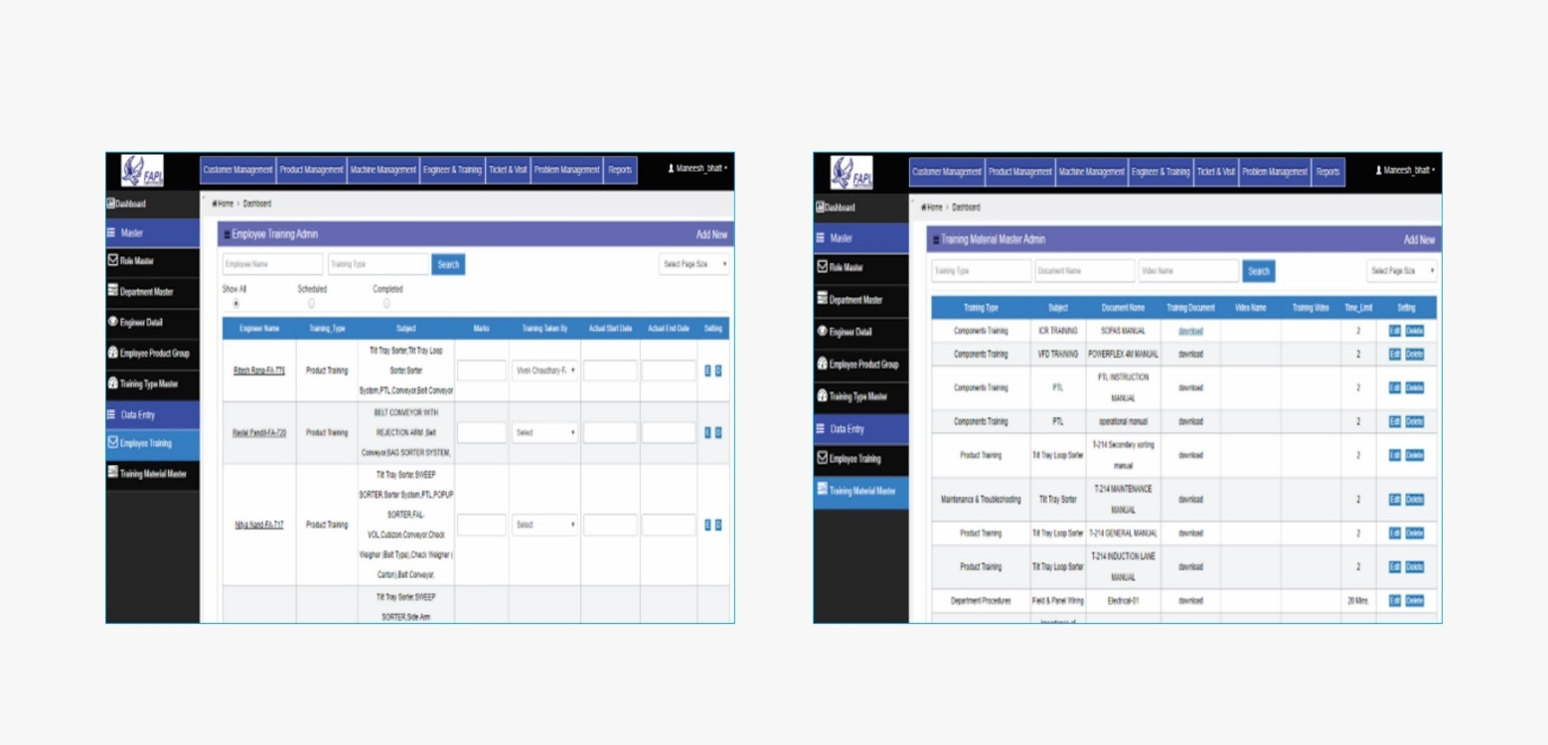

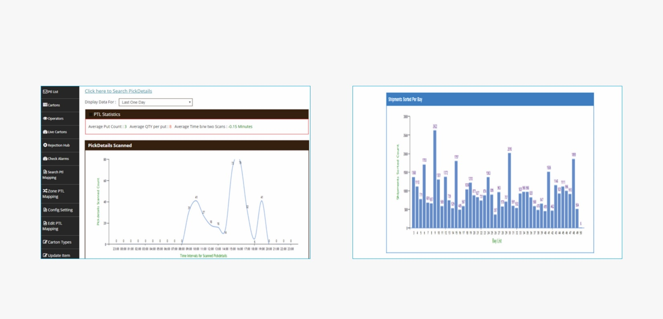
Operational Analysis

Program Organisation
Note- Approx. 60 - 90 days required to handover the system from the date of formal confirmation.

Program Management
For this program, proposed approach covers the following aspects:
- Creation and monitoring of the project plan.
- Communication with FESTO
- Scheduling of the resource management.
- Management of the risks and opportunities.
- Management of the list of anomalies or reservations.

Warranty Period
Falcons offered System comes with a standard warranty of 1 year (Starts from the date of beneficiary use) and post completion of warranty, customer can opt for Extended warranty. Warranty covers the following support:
- 24 X 7 Telephonic, Email and Remote Service Support when required
- Regular Software updates and Bug Fixes.
- Supply of Mechanical and Electrical components in case of failure (excluding damages as mentioned in Exclusion Clause)
The warranty does not apply to replacement or repair of:
- Normal wear and tear.
- Consumables.
- Faulty articles continued:
  - Failure to comply with the manufacturer's recommendations (logistics documentation, Technical Information Note, retrofit document) and the rules of the trade.
  - Negligence or abnormal use of equipment.
  - Anomalies produced by an environment of use, storage or transport that does not comply with the specifications or recommendations of Falcon: packaging, temperature, hygrometry, sector, insulation, etc.
  - A defect due to a cause external to the supplies and services of Falcon.
- Equipment other than that supplied by Falcon.
- Items that can be repaired exclusively by Falcon that have been repaired or attempted repairs other than those carried out by Falcon.
- Items that fail due to normal wear and tear of one or more of its components or whose tamper-evident seals (varnish, strip, etc.) have been broken or whose serial numbers have been removed or modified.
- Items damaged during transport to Falcon due to the use of unsuitable packaging.

Exclusions
The scope of supply includes all parts which are defined in the Supplier’s quotation.

All other parts which are not defined in the Supplier’s quotation do not belong to the Supplier’s scope of supply and are excluded. The following parts are also excluded:

- Servers
- Building infrastructure; building structure, doors, fire exits, levelling devices, building extinguisher and fire alarm system, building heating and lighting system.
- Electrical power supply and wiring to the main control cabinets
- UPS for Controls and Drives
- Electrical Power for Installation
- Network Cabling up to the Main Server Rack
- Intermediate wiring to parts which are to be supplied by the Purchaser/others
- Emergency/Uninterruptable power supply
- Fire-alarm and fire protection devices
- Traffic and route markings
- Laydown Area
- Ram protection devices
- Cat walks, bridges, maintenance aisles and platforms- If not specified
- Assembly tools like forklifts and hoisting machines
- All kind of network incl. Local Area Network (LAN/WLAN), exceeding the scope described in Scope of Supply
- Any Kind of Civil work
- Any adjustment of the Supplier’s scope of supply to local rules and regulations
- X-Ray machines
- Roller cages/ Pallets
- Simulation and 3D animation of the sorter system
- Interface with other equipment not specified in this offer.
- Provision of facilities for the control room (furniture, air conditioning, heating, etc.).
- The supply and installation of fencing around the different corridors.
- Any item specifically indicated as not forming part of the subject matter of the Seller's supply in the offer documentation.

